ANEXOS “ANÁLISIS PARA LA DETERMINACIÓN DE LA TARIFA DE TAXI CONVENCIONAL EN EL CANTÓN NABÓN”

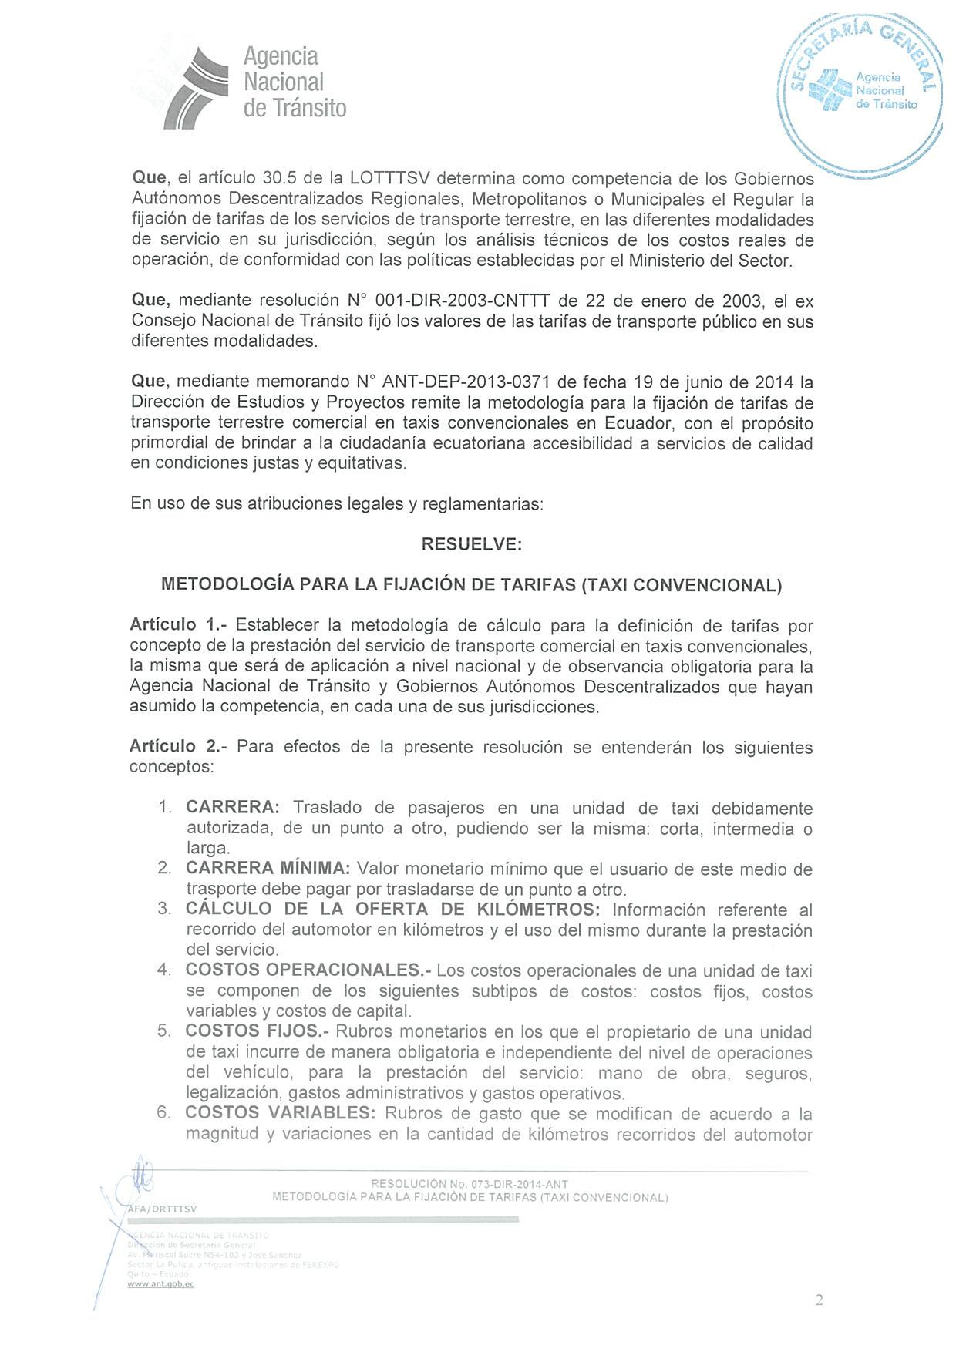
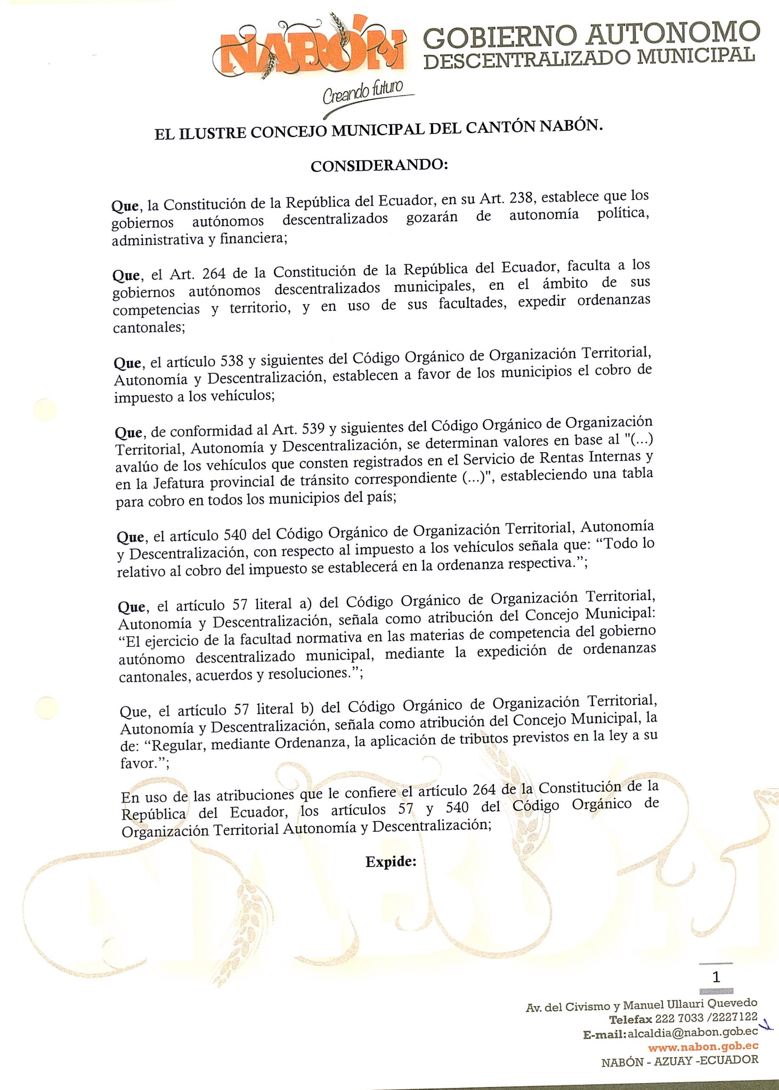
ANEXO 1

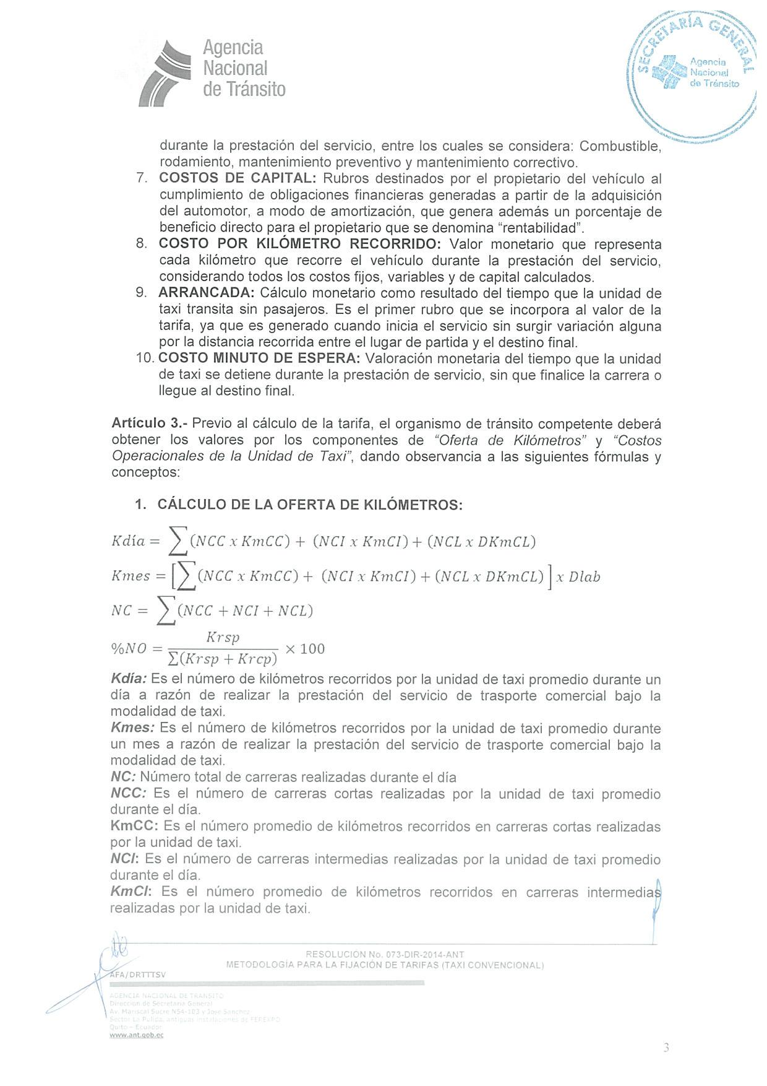
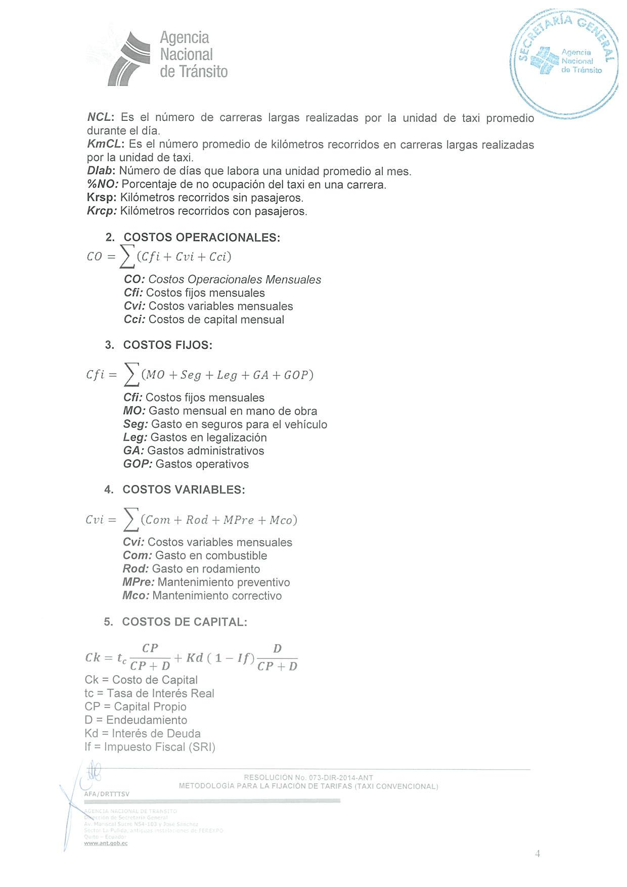
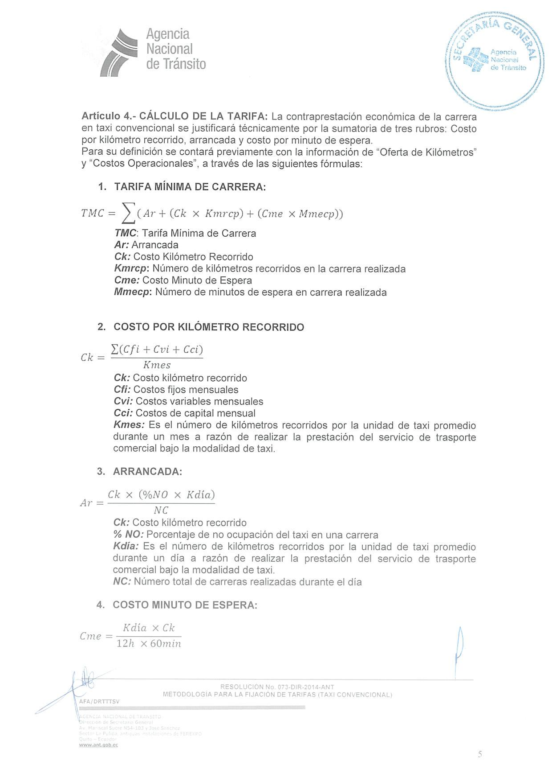
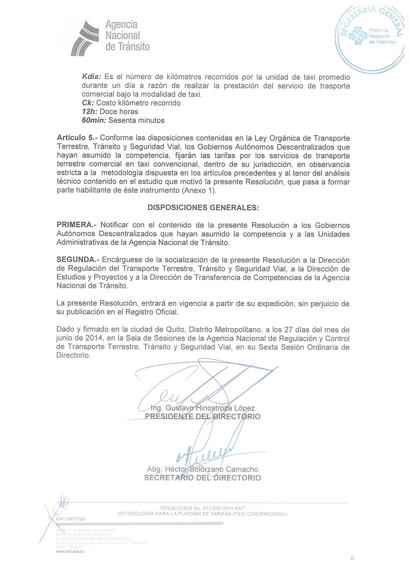
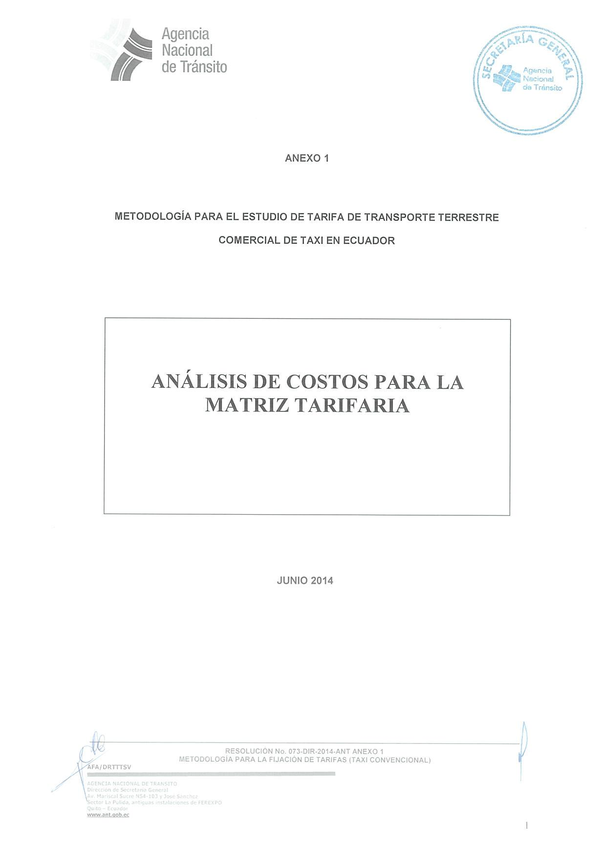
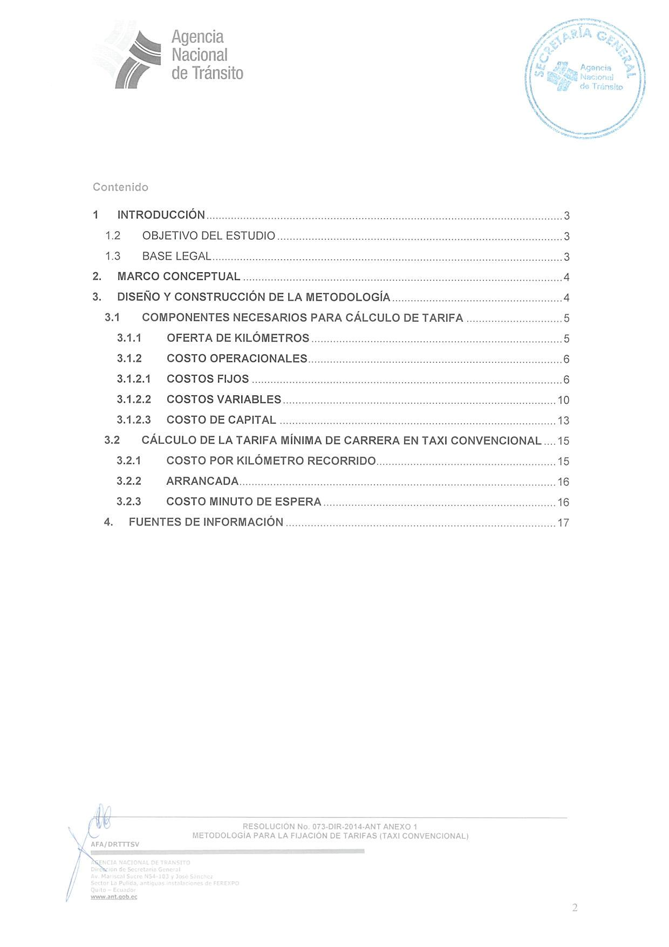
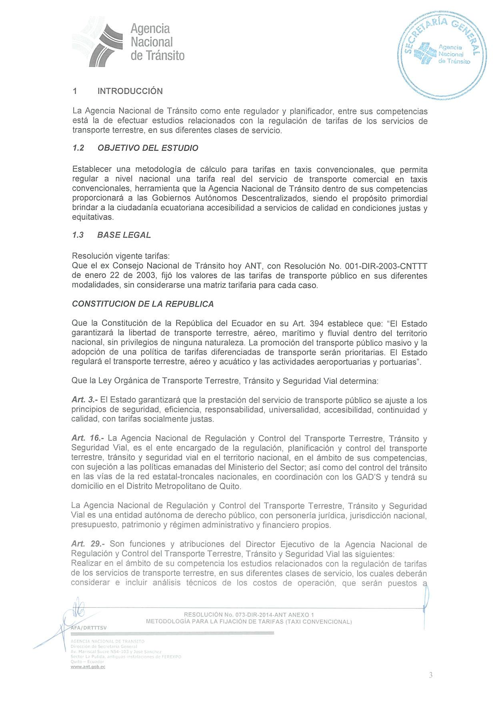
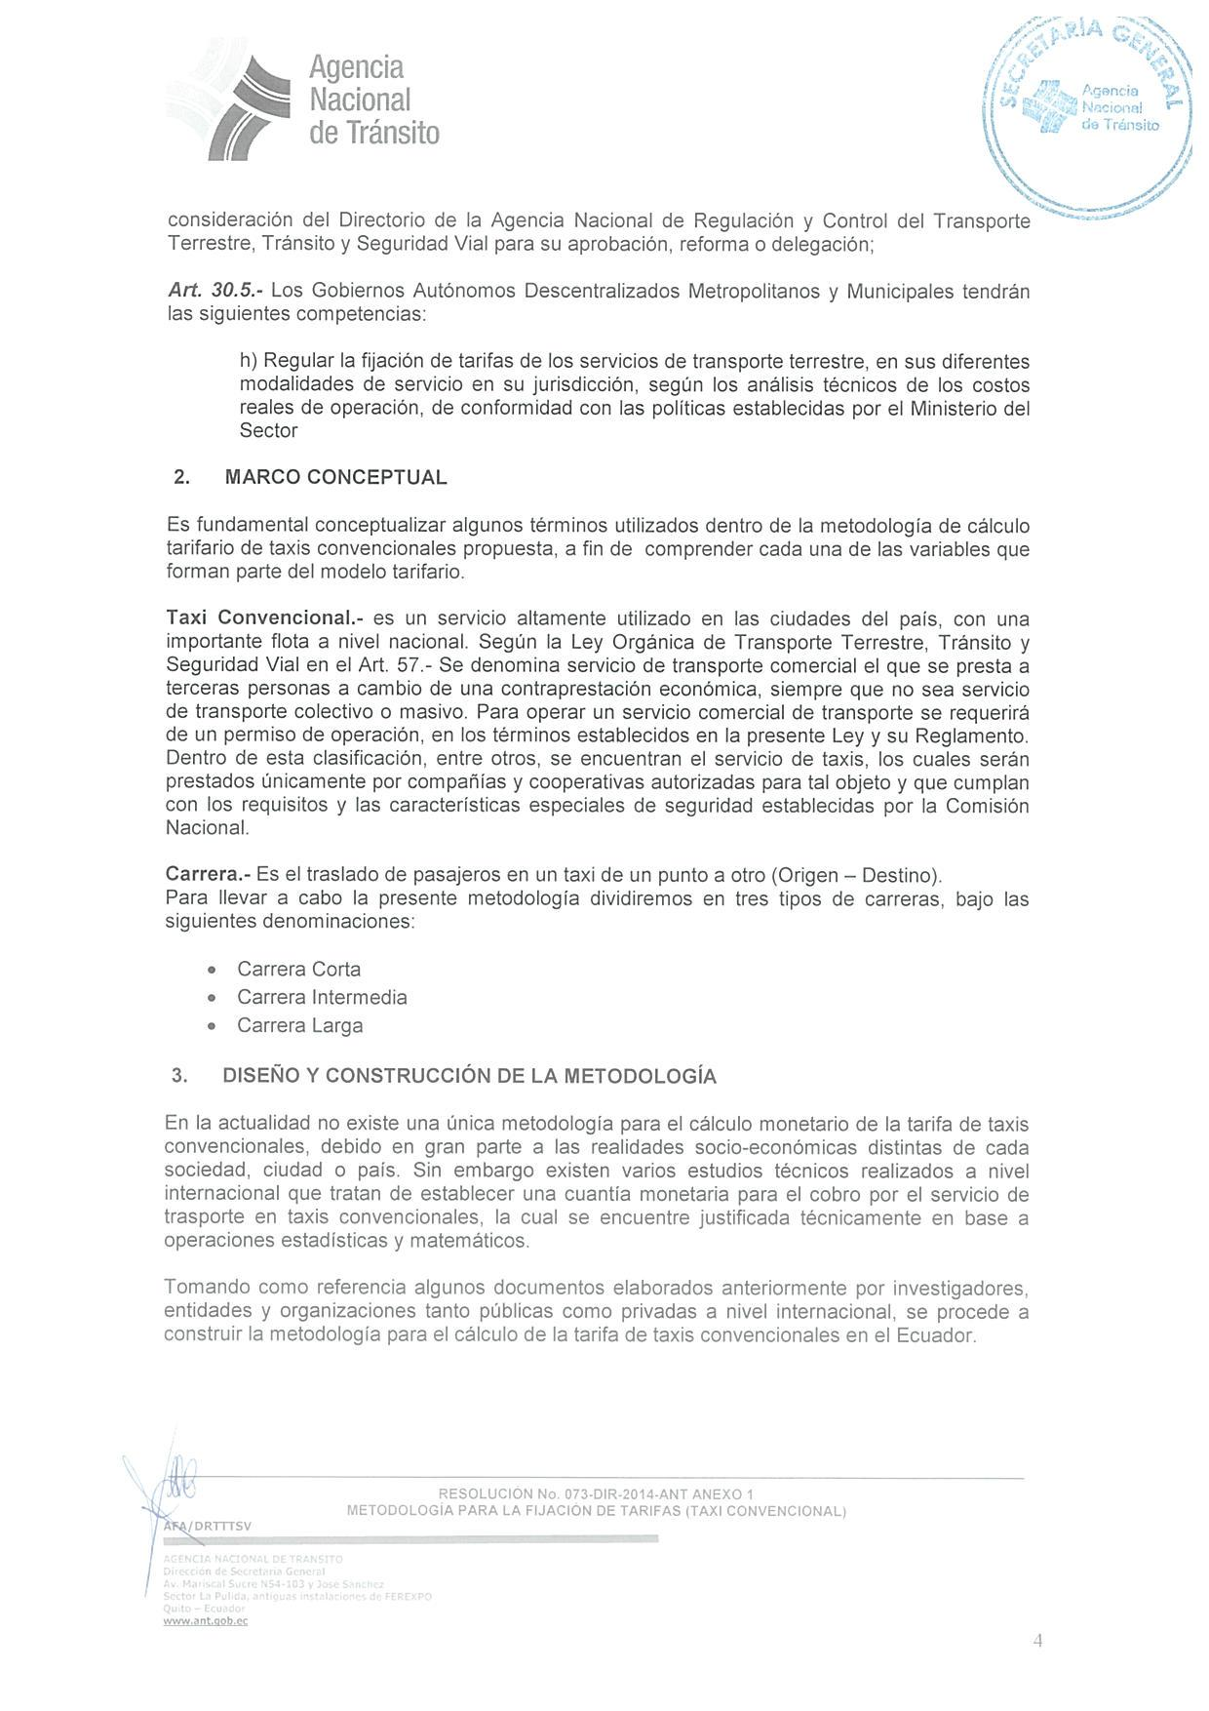
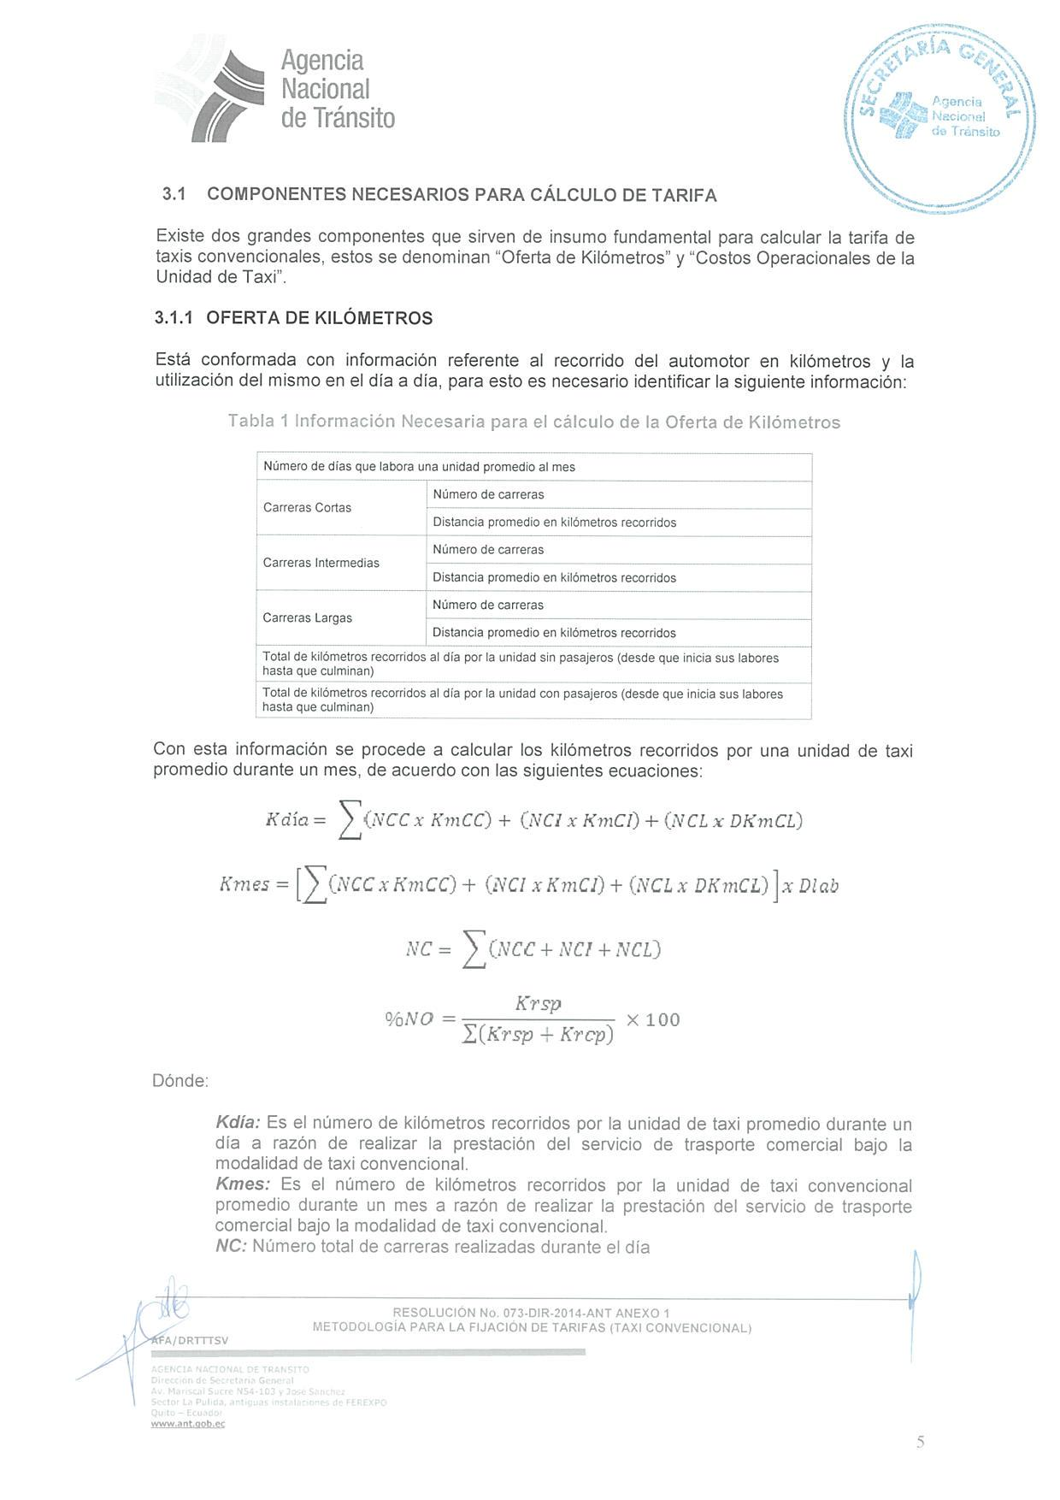
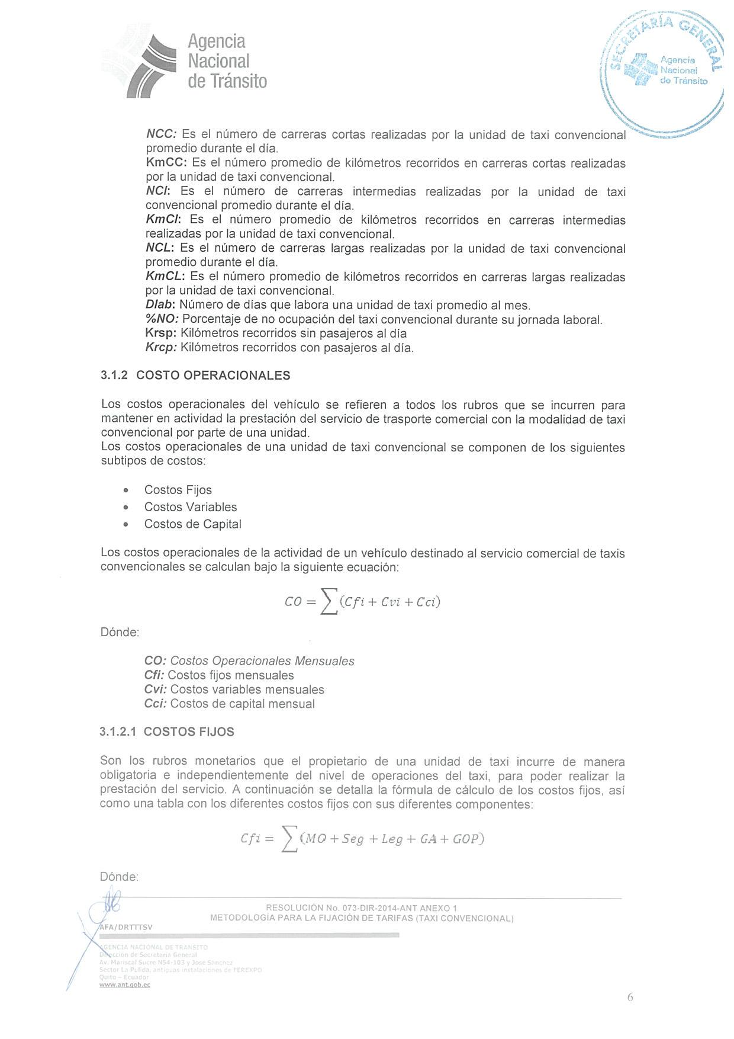
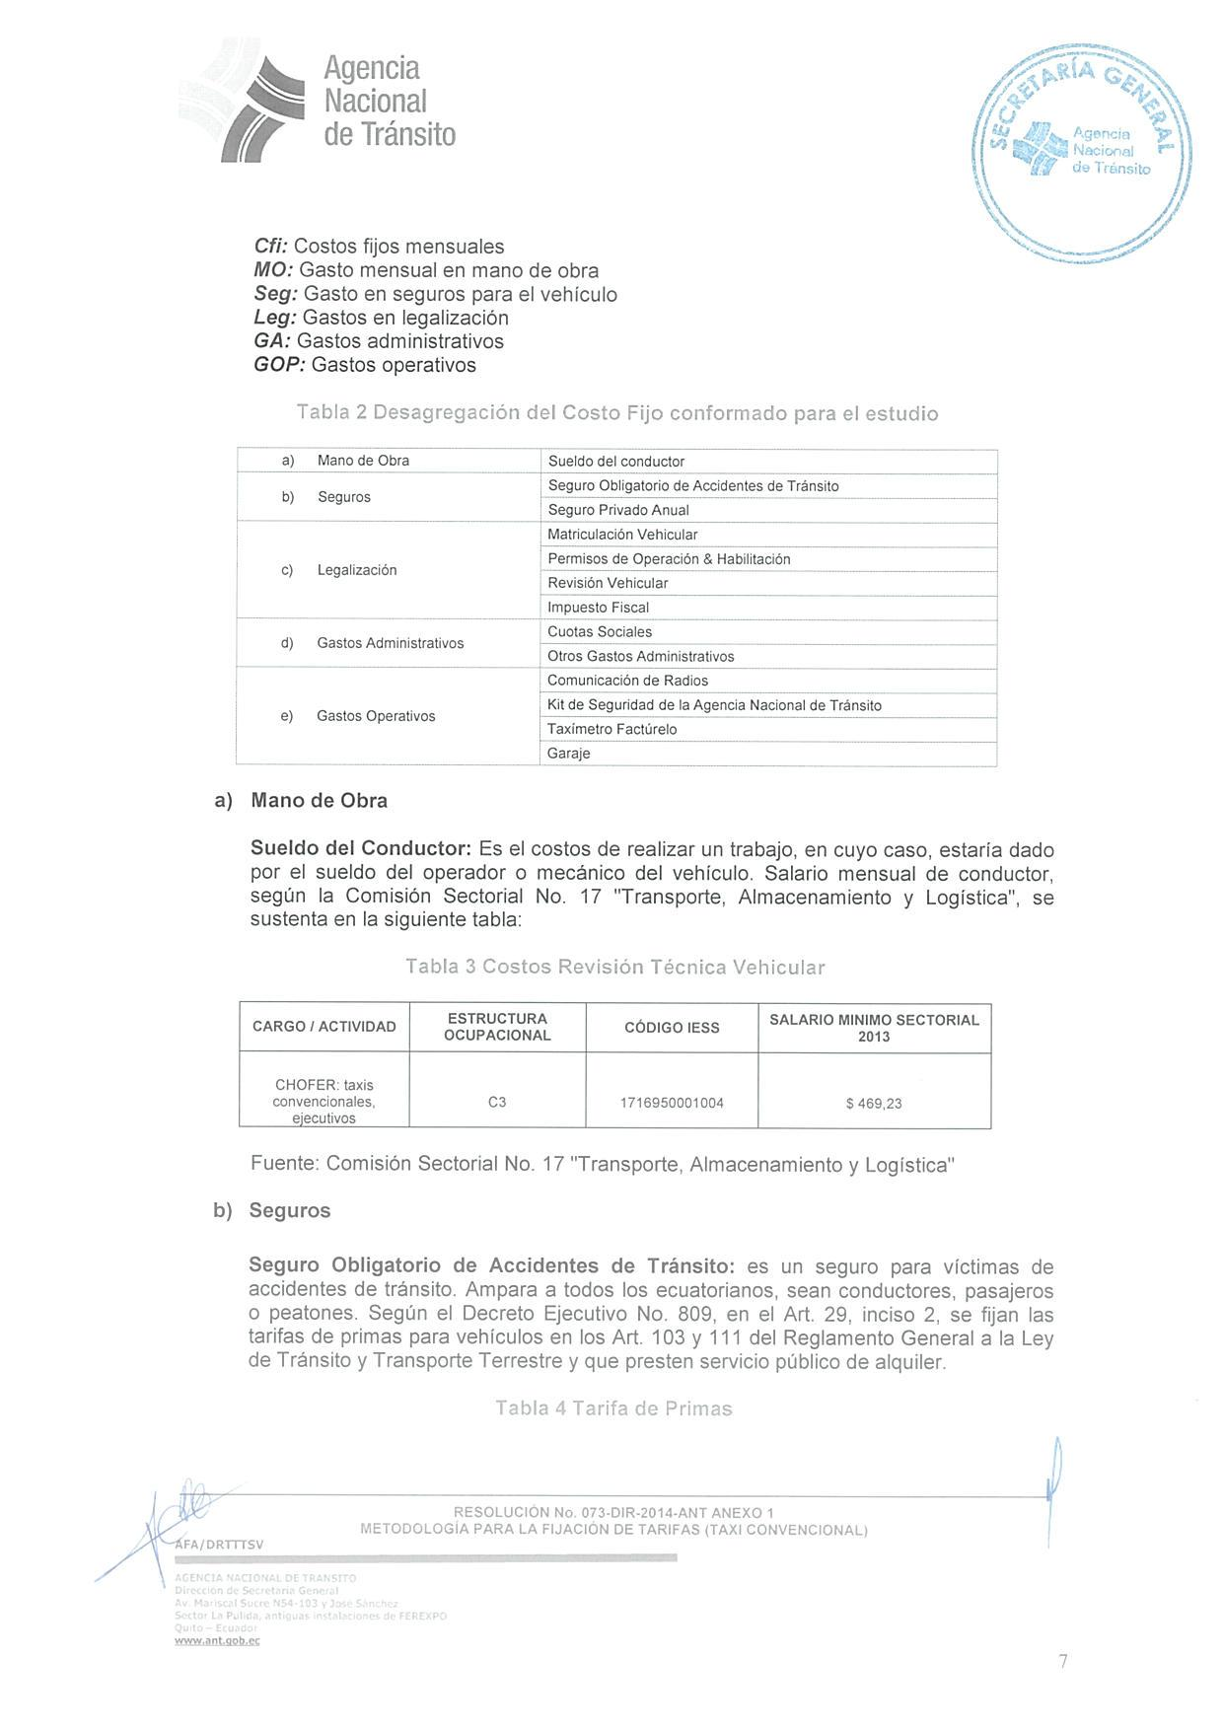
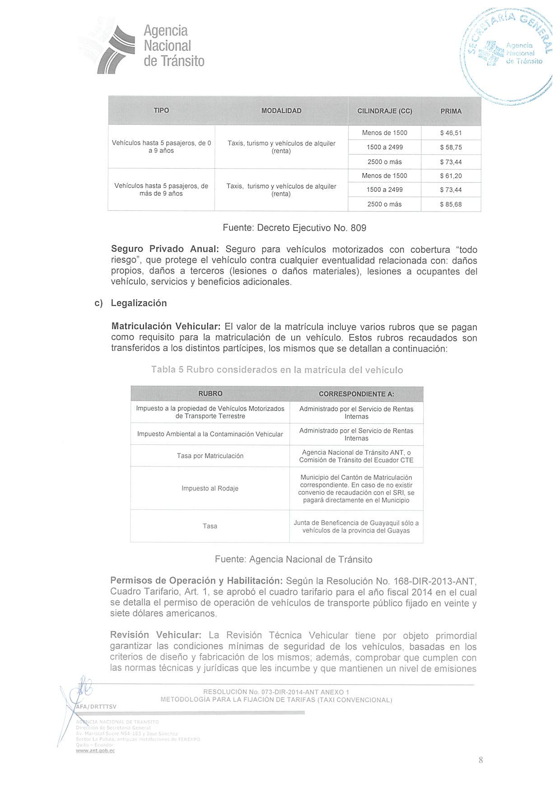
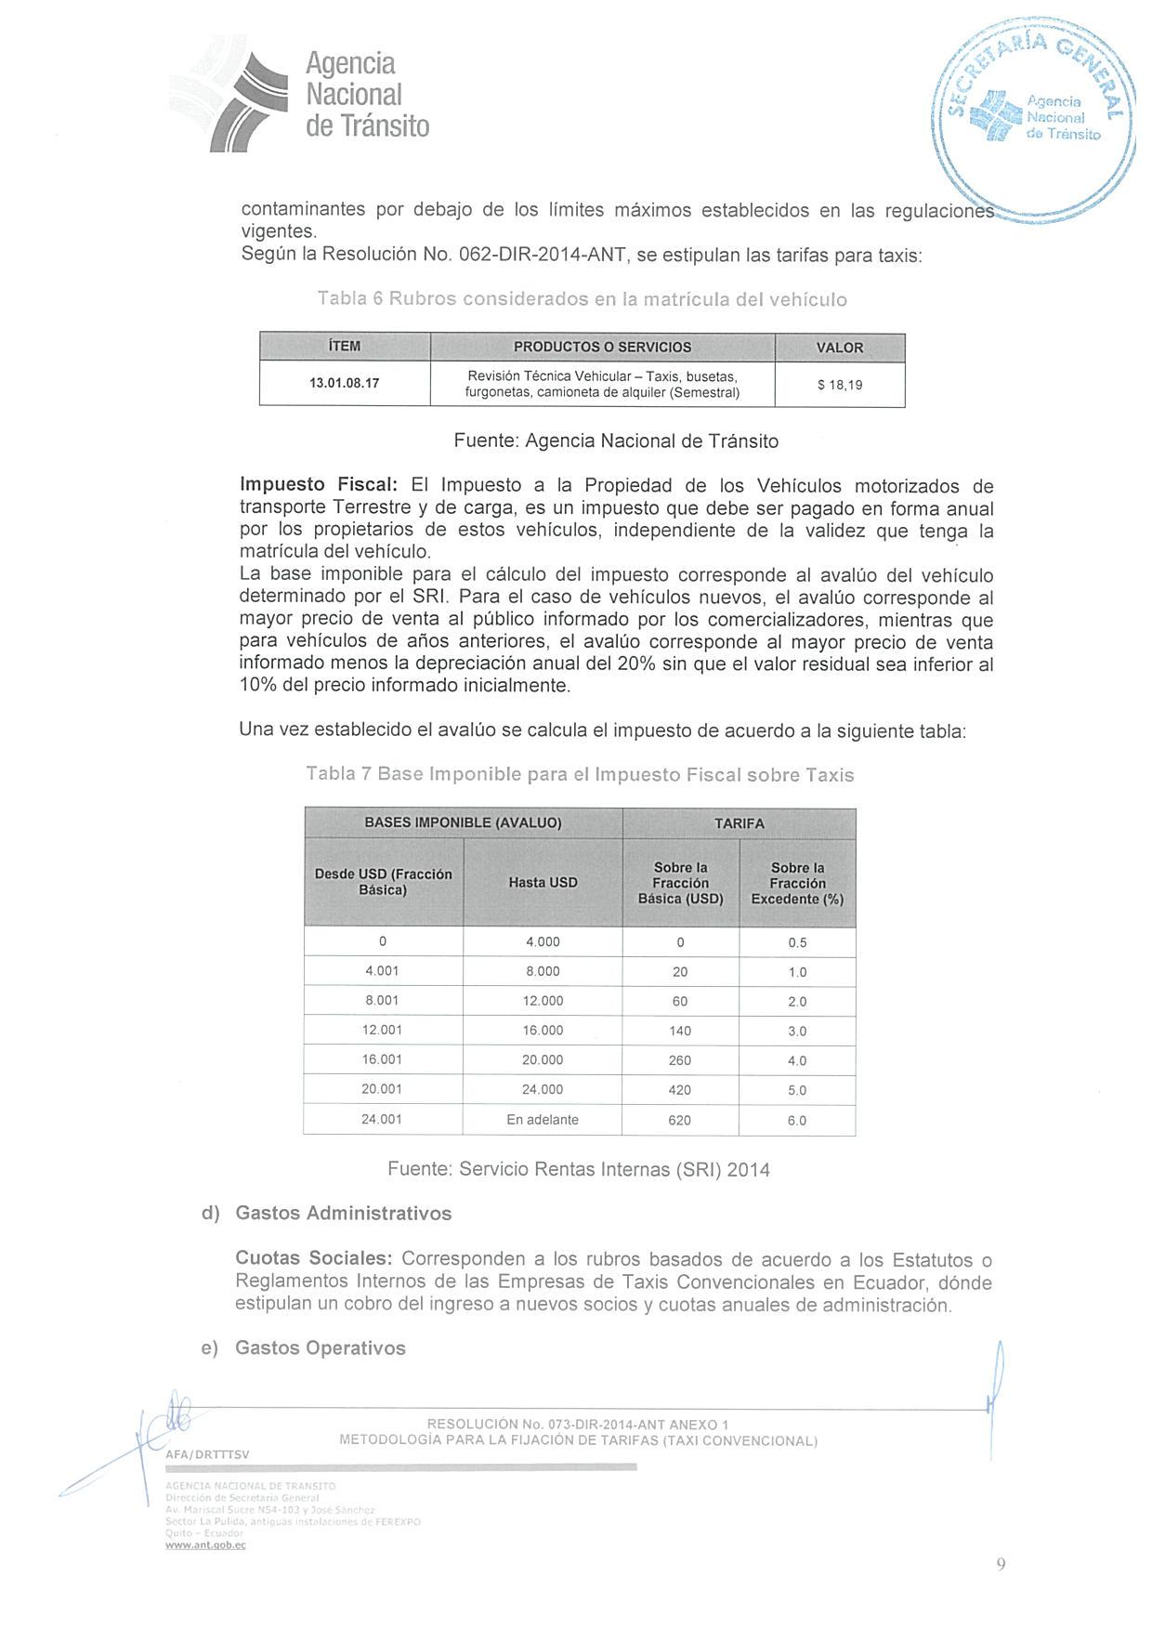
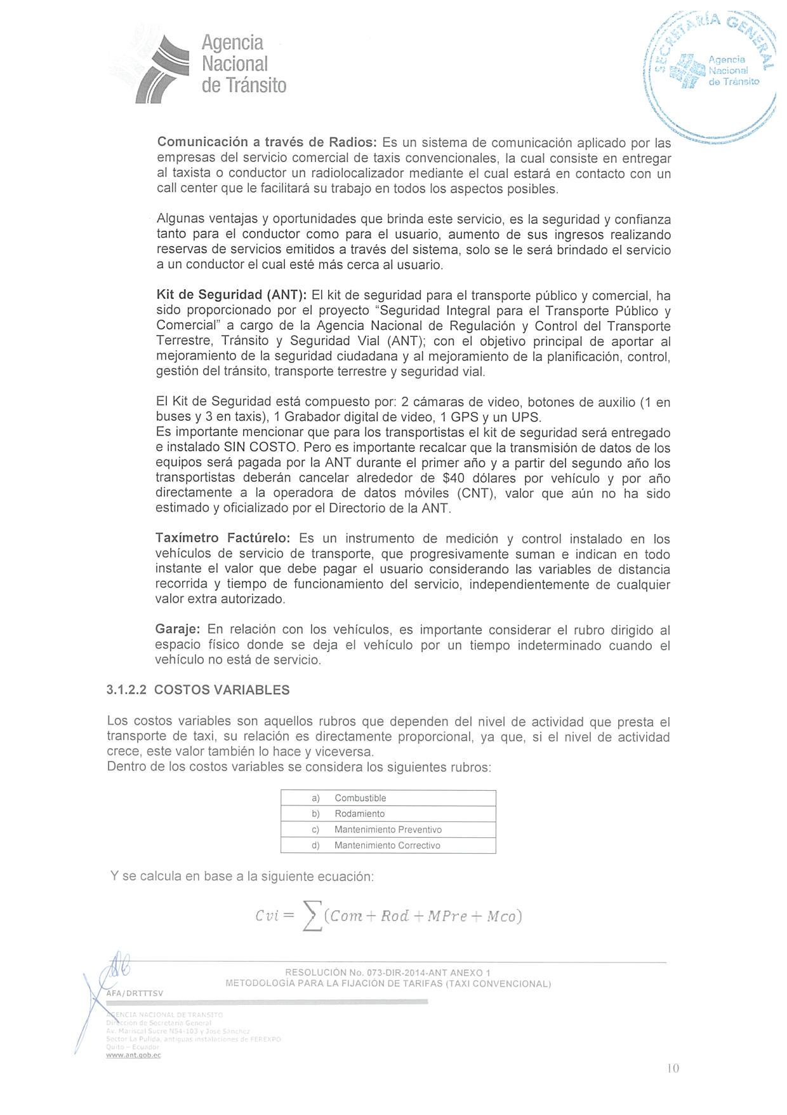
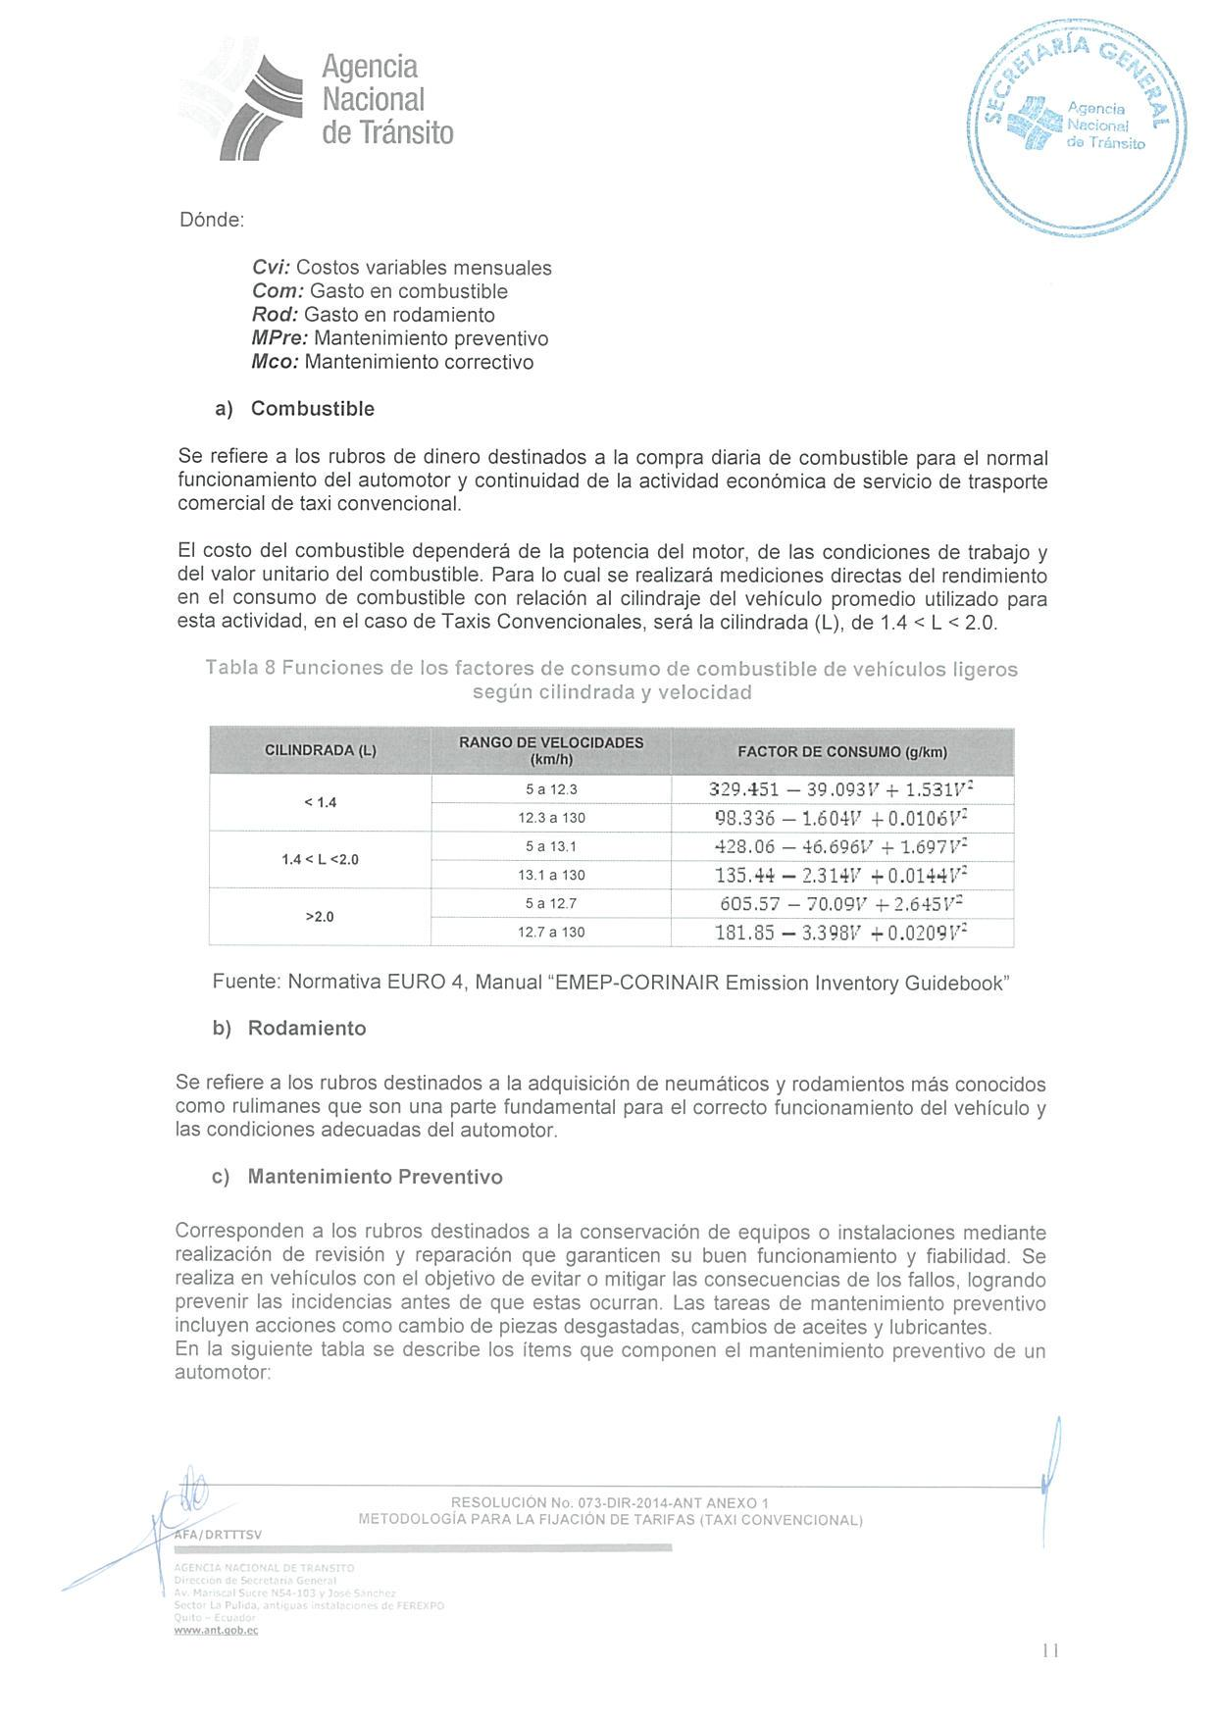
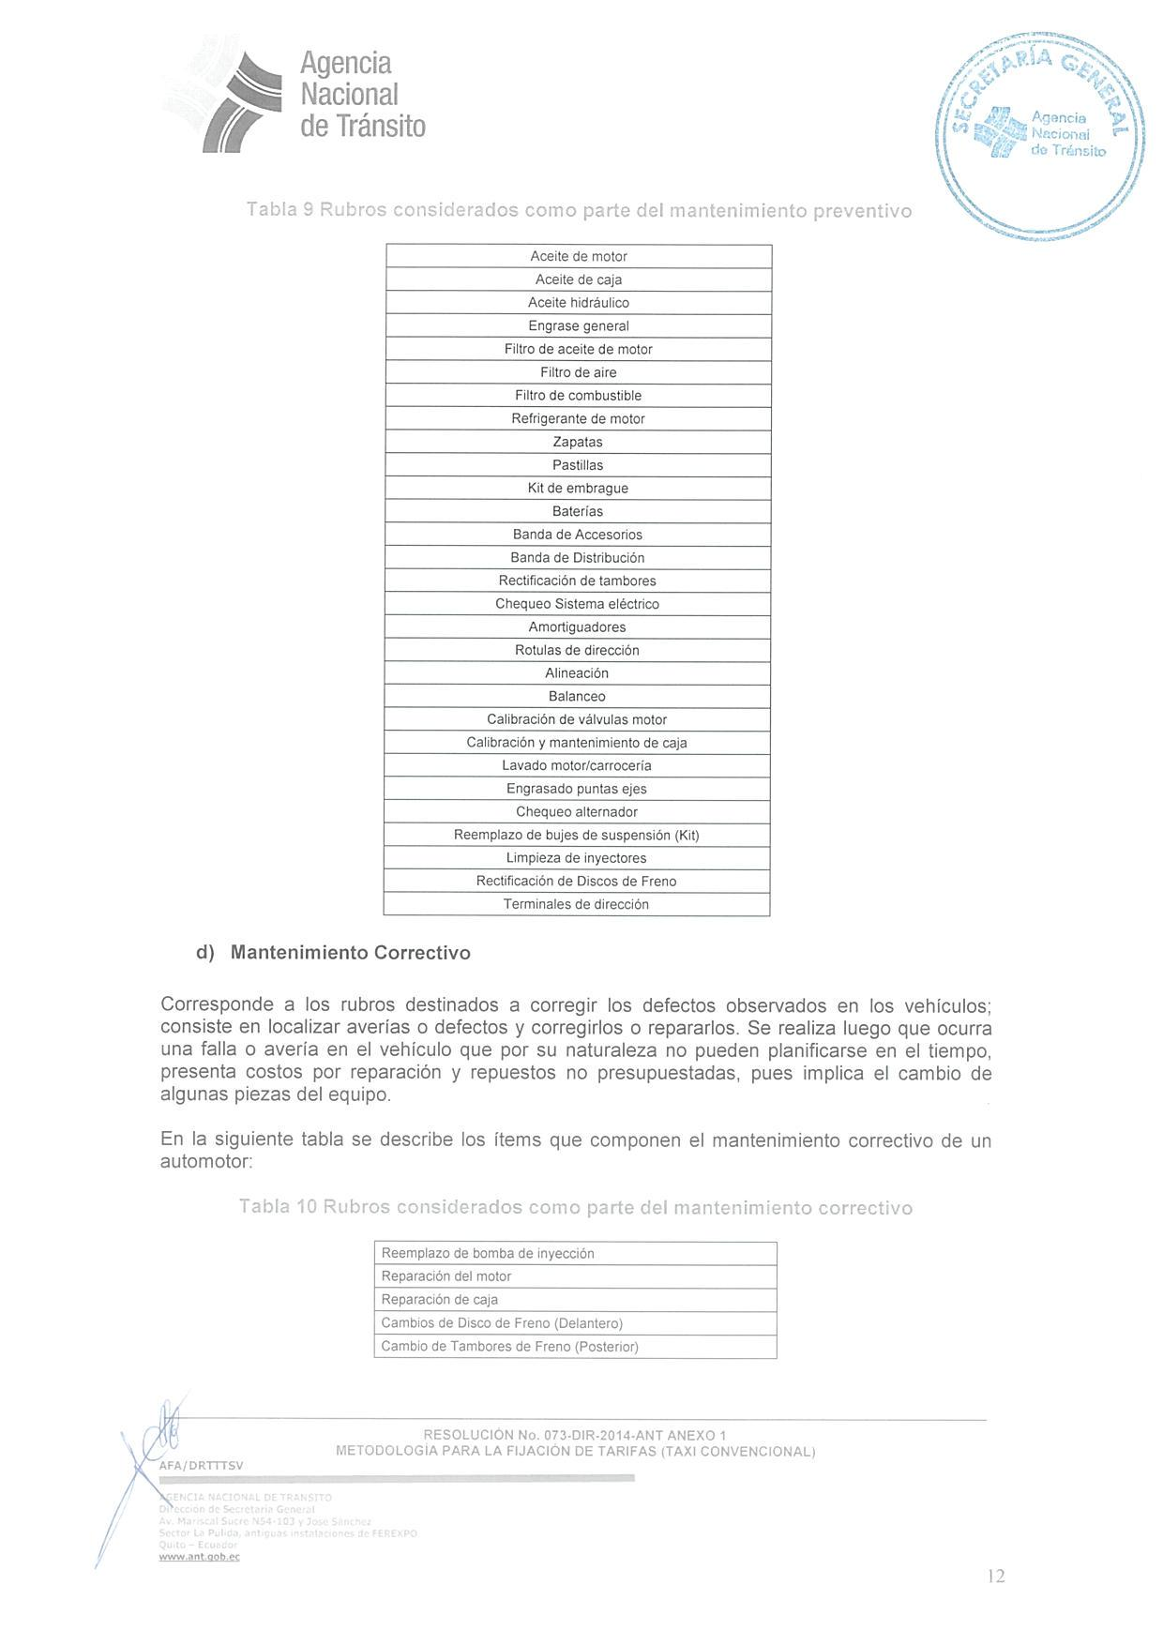
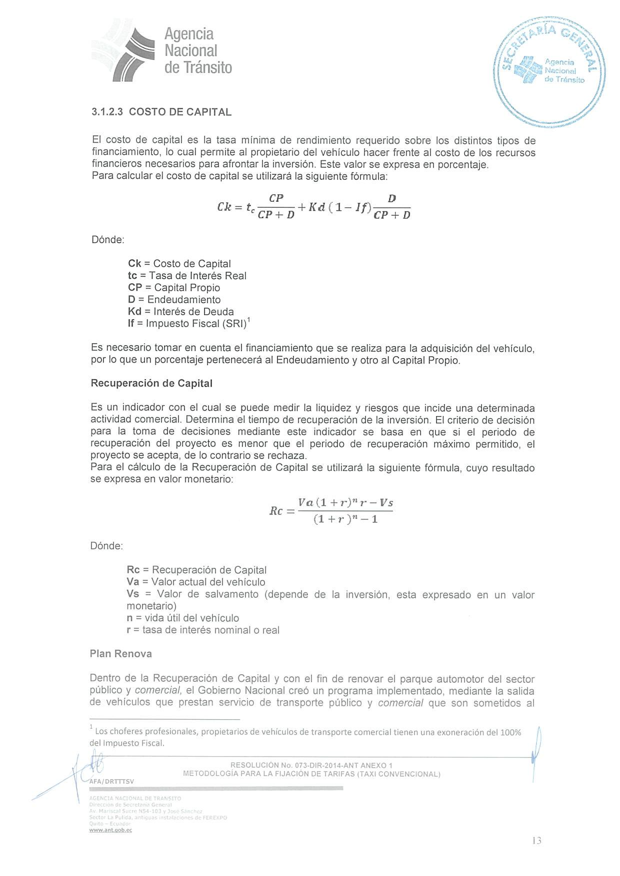
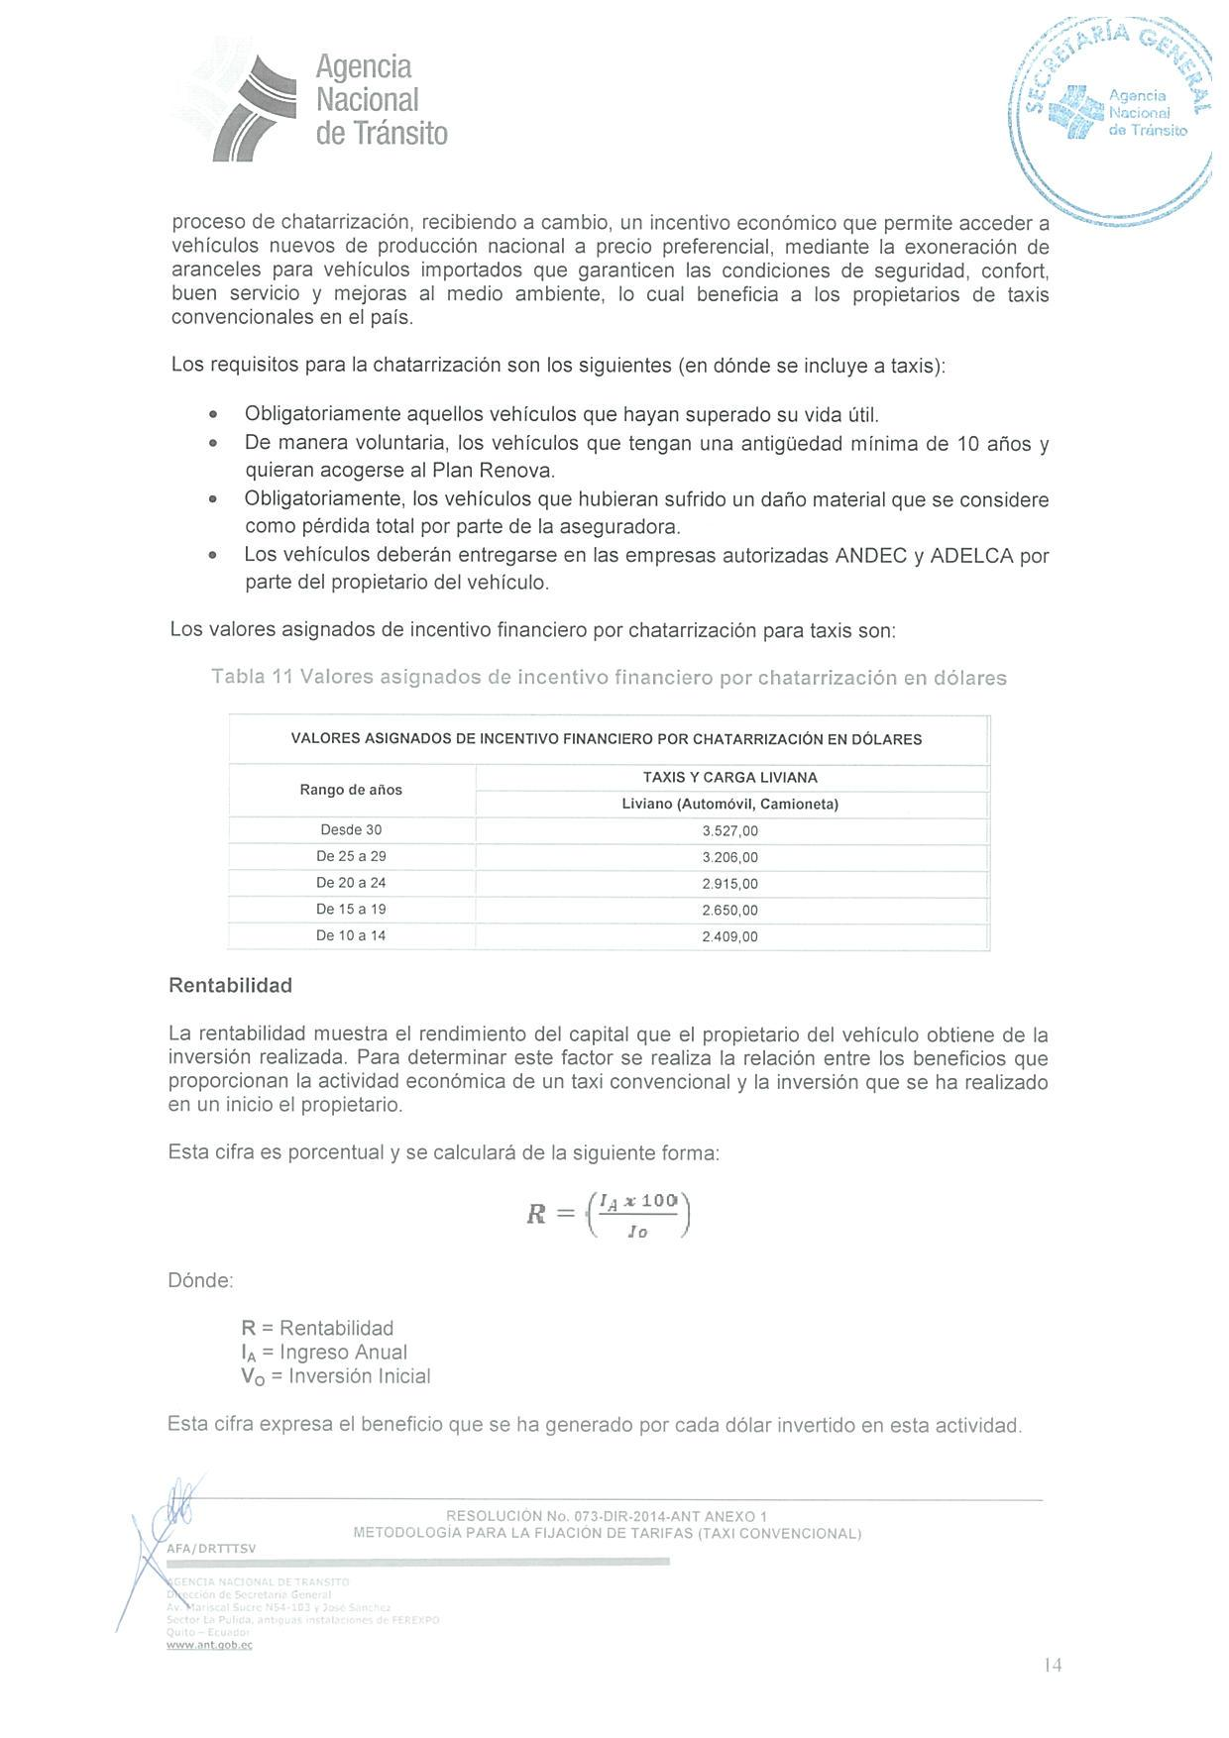
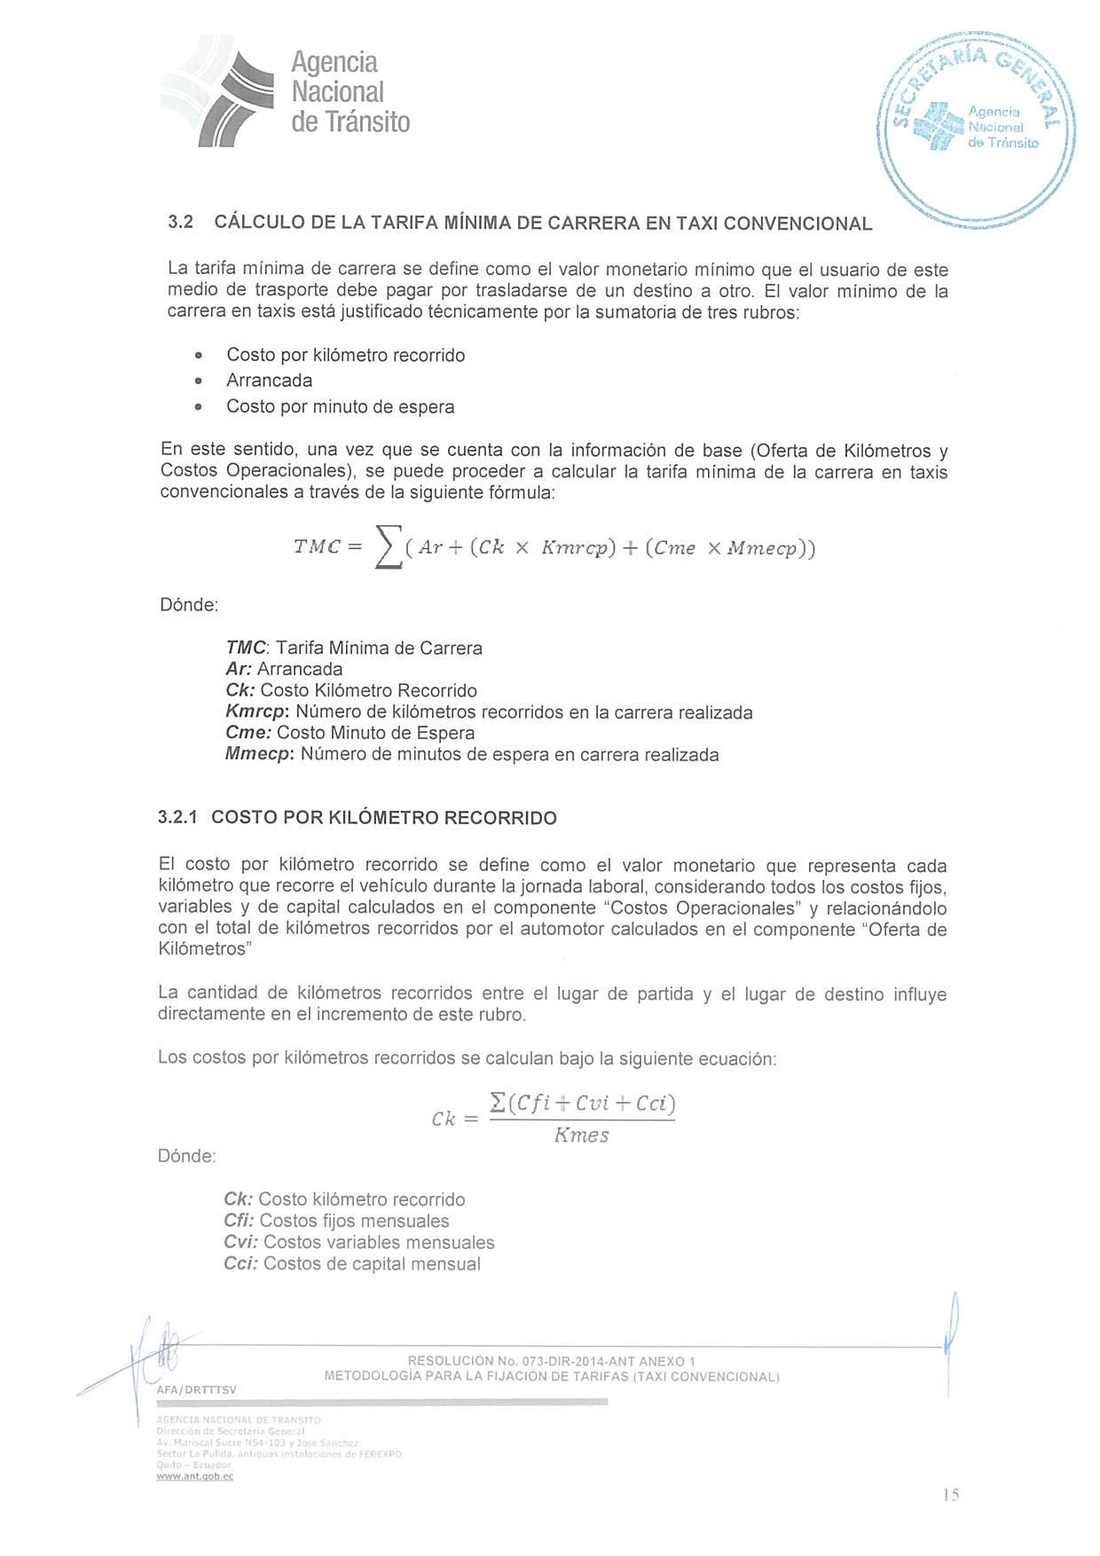
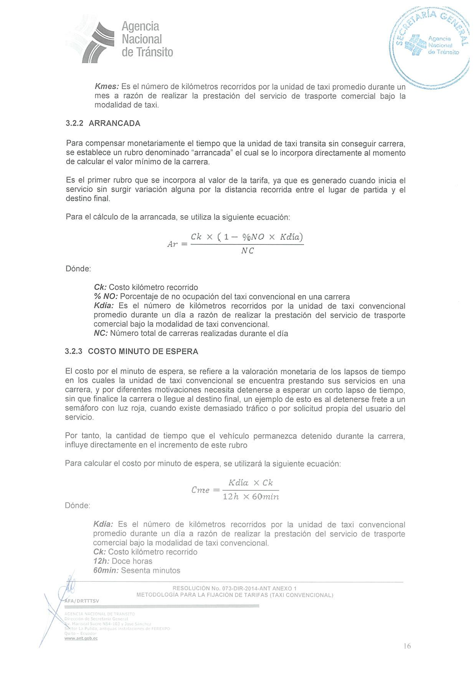
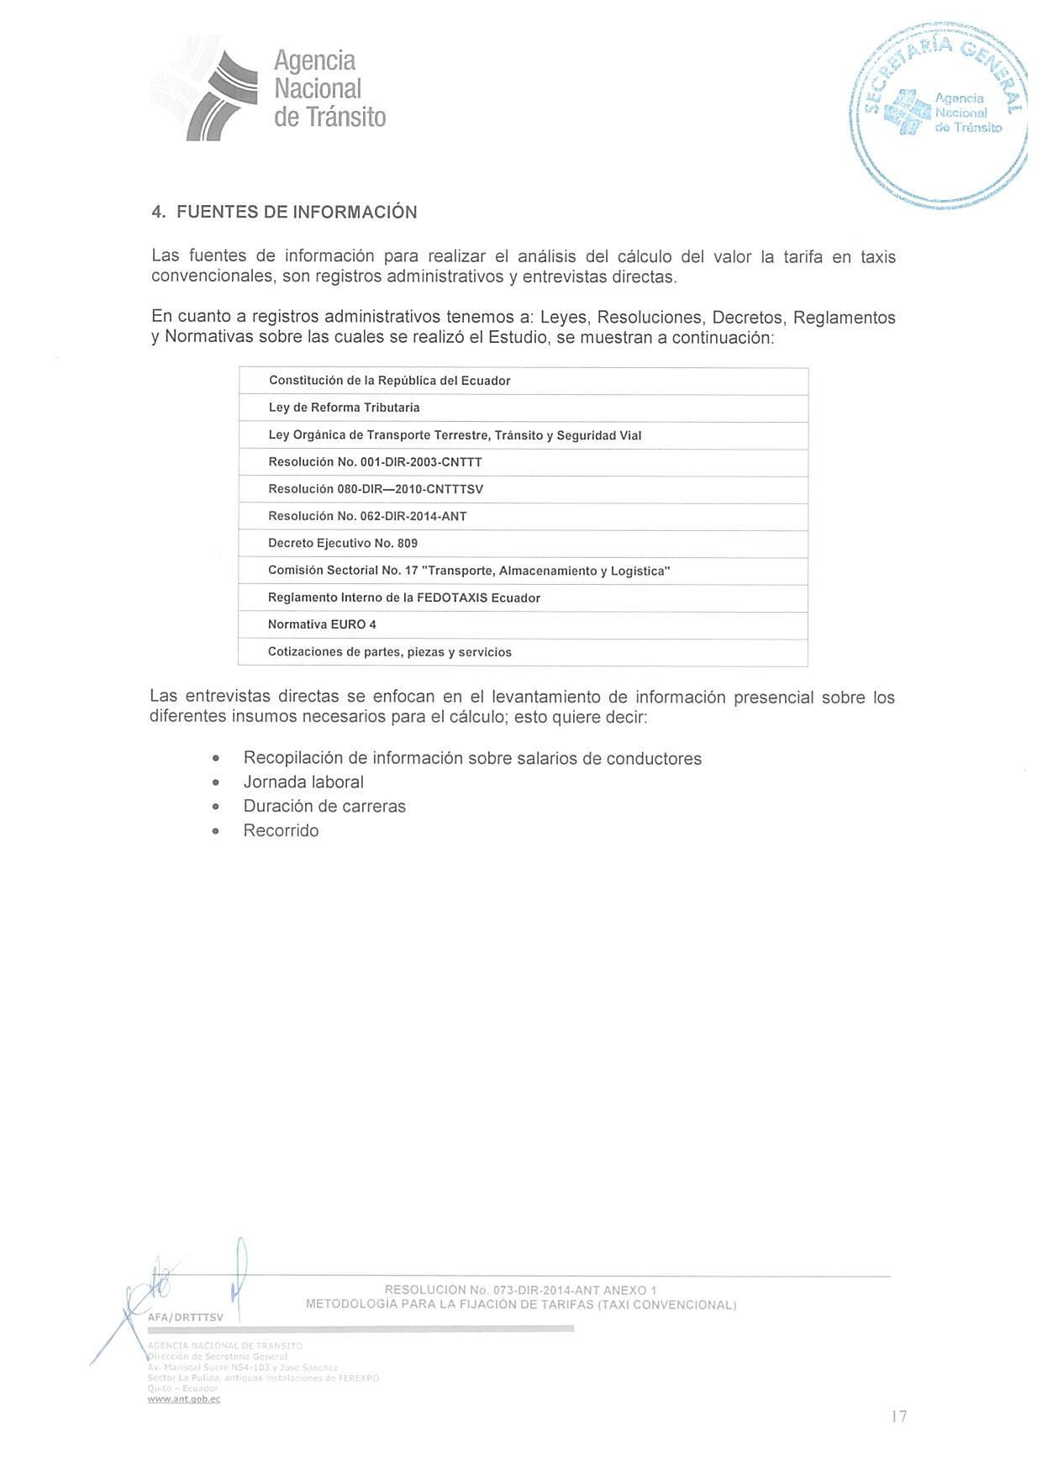
ANEXO 2

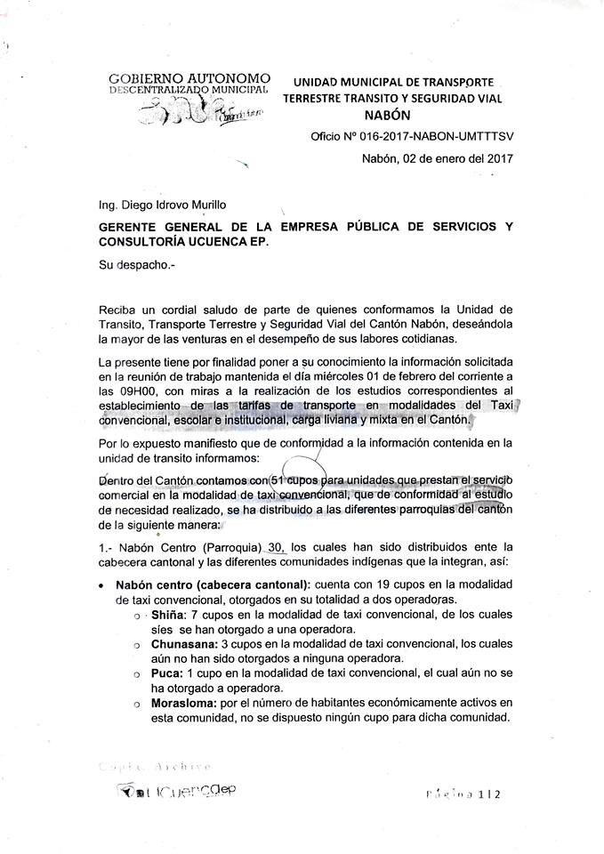
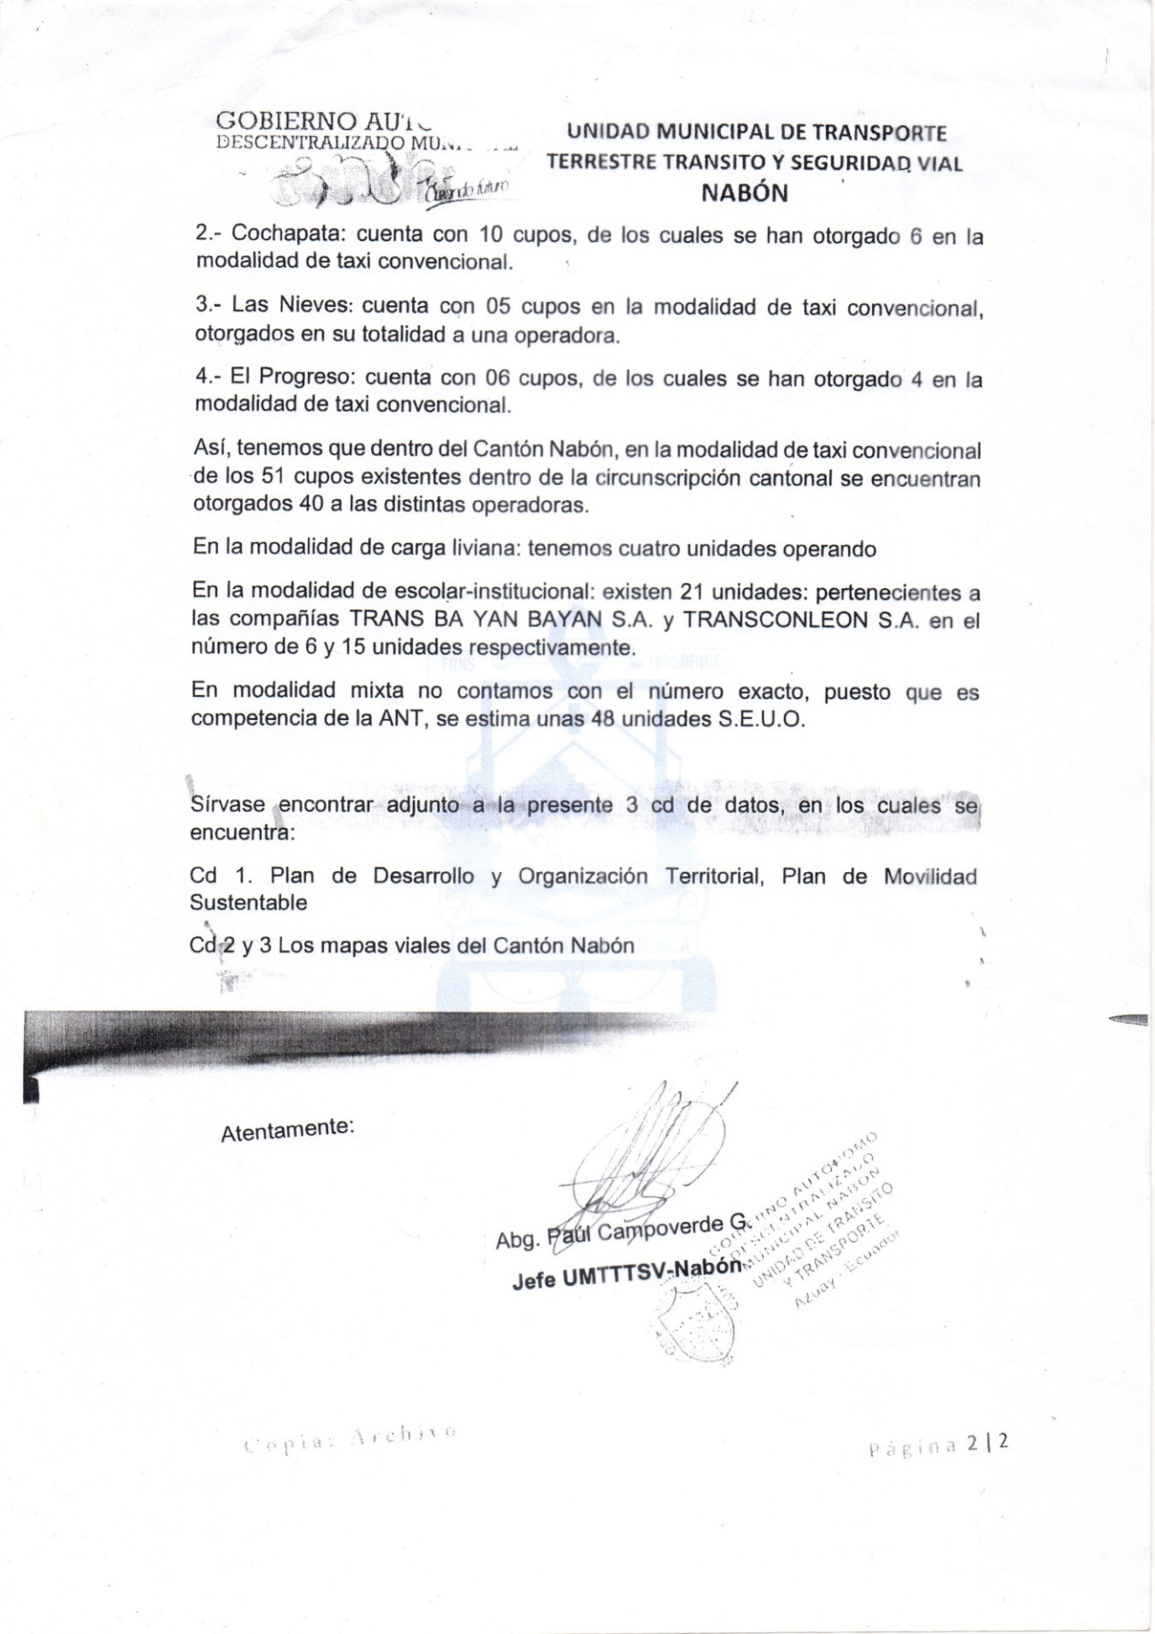ANEXO 3
Parque automotor que labora en el cantón Nabón bajo la modalidad de taxi convencional ejecutivo.

N. | MARCA | MODELO | TIPO | AÑO | Placa | Cilindraje | Cooperativa
1 | Hyundai | Accent 1.6 4P 4x2 | Sedan | 2017 | ABF-2014 | 1.4L | TAXIS PANAMERICANA SUR S.A
2 | Chevrolet | Aveo Emotion AC TM 1.6 4P 4X2 | Sedan | 2013 | SFI-3689 | 1.6L | TAXIS PANAMERICANA SUR S.A
3 | Chevrolet | Aveo Activo 1.6 4P STD | Sedan | 2010 | LBA-3060 | 1.6L | TAXIS PANAMERICANA SUR S.A
4 | Chevrolet | AVEO FAMILY STD1.5 4X2 | Sedan | 2016 | AAA4109 | 1.6L | TAXISTRANSROSARIO C.A
5 | Chevrolet | AVEO FAMILY STD1.5 4X2 | Sedan | 2016 | AAA4108 | 1.6L | TAXISTRANSROSARIO C.A
6 | Chevrolet | AVEO FAMILY STD1.5 4X2 | Sedan | 2016 | AAA4107 | 1.6L | TAXISTRANSROSARIO C.A
7 | Chevrolet | AVEO FAMILY STD1.5 4X2 | Sedan | 2016 | AAA4110 | 1.6L | TAXISTRANSROSARIO C.A
8 | Chevrolet | AVEO FAMILY STD1.5 4X2 | Sedan | 2016 | AAA4111 | 1.6L | TAXISTRANSROSARIO C.A
9 | Hyundai | ACCENT 4P 1.4 | Sedan | 2010 | PBL-5585 | 1.4L | TRANSTAXIELPROGRESO C.A
10 | NISSAN | SENTRA 1.6 M/T | Sedan | 2011 | ABB-6892 | 1.6L | TRANSTAXIELPROGRESO C.A
11 | Chevrolet | Aveo activo 1.6L 4P AC | Sedan | 2009 |  | 1.6L | TRANSTAXIELPROGRESO C.A
12 | Chevrolet | AVEO EMOTION 1.6L STD | Sedan | 2008 | PBA-6680 | 1.6L | TRANSTAXIELPROGRESO C.A
13 | Chevrolet | AVEO FAMILY STD1.5 4X2 | Sedan | 2017 | ABF-8353 | 1498 C.C | TAXISCOCHAPATA S.A
14 | Chevrolet | AVEO EMOTION | Sedan | 2017 | ABF-8397 | 1.6L | TAXISCOCHAPATA S.A
15 | Chevrolet | AVEO FAMILY | Sedan | 2017 | ABF-2370 | 1498 C.C | TAXISCOCHAPATA S.A
16 | Chevrolet | SAIL 1.4 4R | Sedan | 2016 | ABF-8429 | 1400 C.C | TAXISCOCHAPATA S.A
17 | Chevrolet | AVEO FAMILY S4D 4X2 | Sedan | 2017 |  | 1498 C.C | TAXISCOCHAPATA S.A
18 | Chevrolet | AVEO FAMILY S4D 4X2 | Sedan | 2017 |  | 1498 C.C | TAXISCOCHAPATA S.A
19 | Chevrolet | AVEO FAMILY | Sedan | 2011 | ABA5444 | 1.6L | TRANSTAXISNABÓN S.A
20 | Chevrolet | AVEO FAMILY | Sedan | 2013 | LBB3619 | 1.6L | TRANSTAXISNABÓN S.A
21 | Chevrolet | AVEO FAMILY | Sedan | 2013 | ABD3246 | 1.6L | TRANSTAXISNABÓN S.A
22 | Chevrolet | AVEO FAMILY | Sedan | 2012 | PBV2084 | 1.6L | TRANSTAXISNABÓN S.A
23 | Chevrolet | AVEO FAMILY | Sedan | 2012 | TBC2160 | 1.6L | TRANSTAXISNABÓN S.A
24 | Chevrolet | AVEO FAMILY | Sedan | 2013 | PBZ1329 | 1.6L | TRANSTAXISNABÓN S.A
25 | Chevrolet | AVEO FAMILY | Sedan | 2015 | ABE2427 | 1.6L | TRANSTAXISNABÓN S.A
26 | Chevrolet | AVEO FAMILY | Sedan | 2011 | ABC2111 | 1.6L | TRANSTAXISNABÓN S.A
27 | Chevrolet | AVEO FAMILY | Sedan | 2012 | PBY6107 | 1.6L | TRANSTAXISNABÓN S.A
28 | Chevrolet | AVEO FAMILY | Sedan | 2011 | PBI5959 | 1.6L | TRANSTAXISNABÓN S.A
29 | Chevrolet | AVEO FAMILY | Sedan | 2013 | ABD1600 | 1.6L | TRANSTAXISNABÓN S.A
30 | Chevrolet | AVEO FAMILY | Sedan | 2011 | IBA5177 | 1.6L | TRANSTAXISNABÓN S.A
31 | Hyundai | ACCENT 4P 4X2TM | Sedan | 2017 |  | 1.4L | ZHIÑAEXPRESS S.A
32 | Chevrolet | AVEO ACTIVO 4P STD | Sedan | 2011 | ABB-3637 | 1.6L | ZHIÑAEXPRESS S.A
33 | Hyundai | ELANTRA | Sedan | 2011 | ABB-7714 | 1.4L | ZHIÑAEXPRESS S.A
34 | Chevrolet | AVEO ACTIVO 4P AC | Sedan | 2011 | PBR-5926 | 1.6L | ZHIÑAEXPRESS S.A
35 | Hyundai | ACCENT 4P 4X2 STD | Sedan | 2013 | CVE-1290 | 1.4L | ZHIÑAEXPRESS S.A
36 | Hyundai | ACCENT TM 4P 4X2 TM | Sedan | 2014 |  | 1.4L | ZHIÑAEXPRESS S.A
37 | Nissan | TIIDA | Sedan | 2015 | AAA4172 | 1600 C.C | SABINTEÑITA S.A
38 | Nissan | TIIDA | Sedan | 2015 | AAA4173 | 1600 C.C | SABINTEÑITA S.A
39 | Nissan | TIIDA | Sedan | 2015 | AAA4171 | 1600 C.C | SABINTEÑITA S.A
40 | Nissan | TIIDA | Sedan | 2015 | AAA4170 | 1600 C.C | SABINTEÑITA S.A
41 | Nissan | TIIDA | Sedan | 2015 | AAA4169 | 1600 C.C | SABINTEÑITA S.A
Fuente: Elaboración del autor a partir de las resoluciones otorgadas por la Unidad municipal de transporte terrestre tránsito y seguridad vial, cantón Nabón.

ANEXO 4
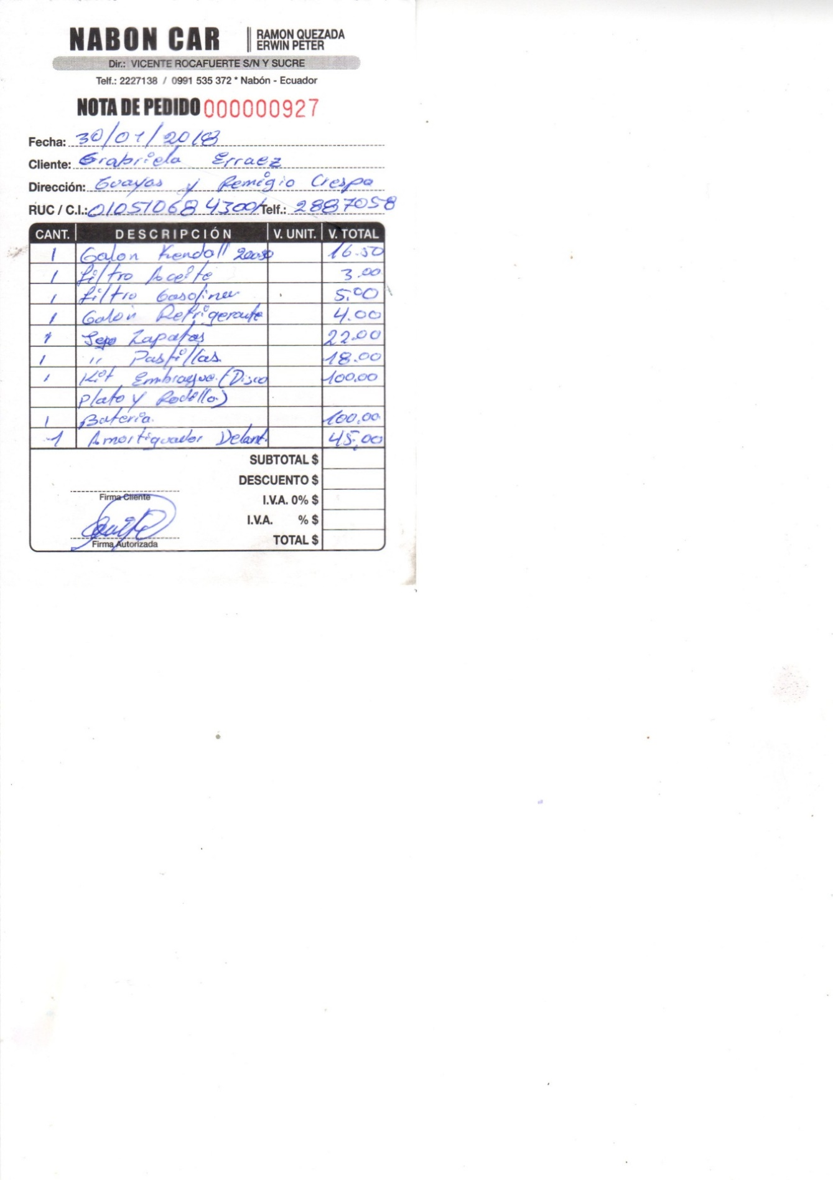
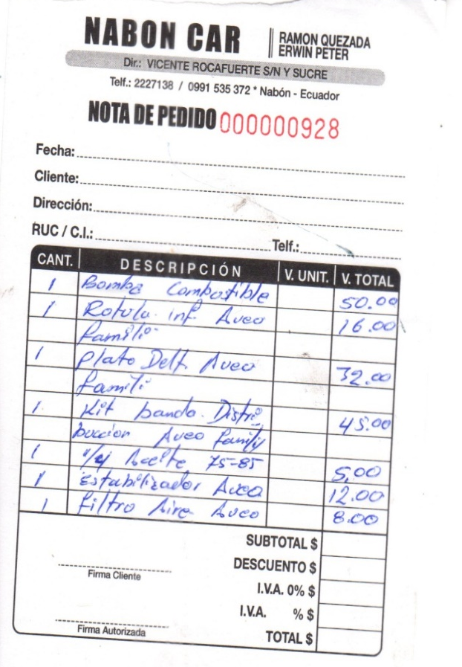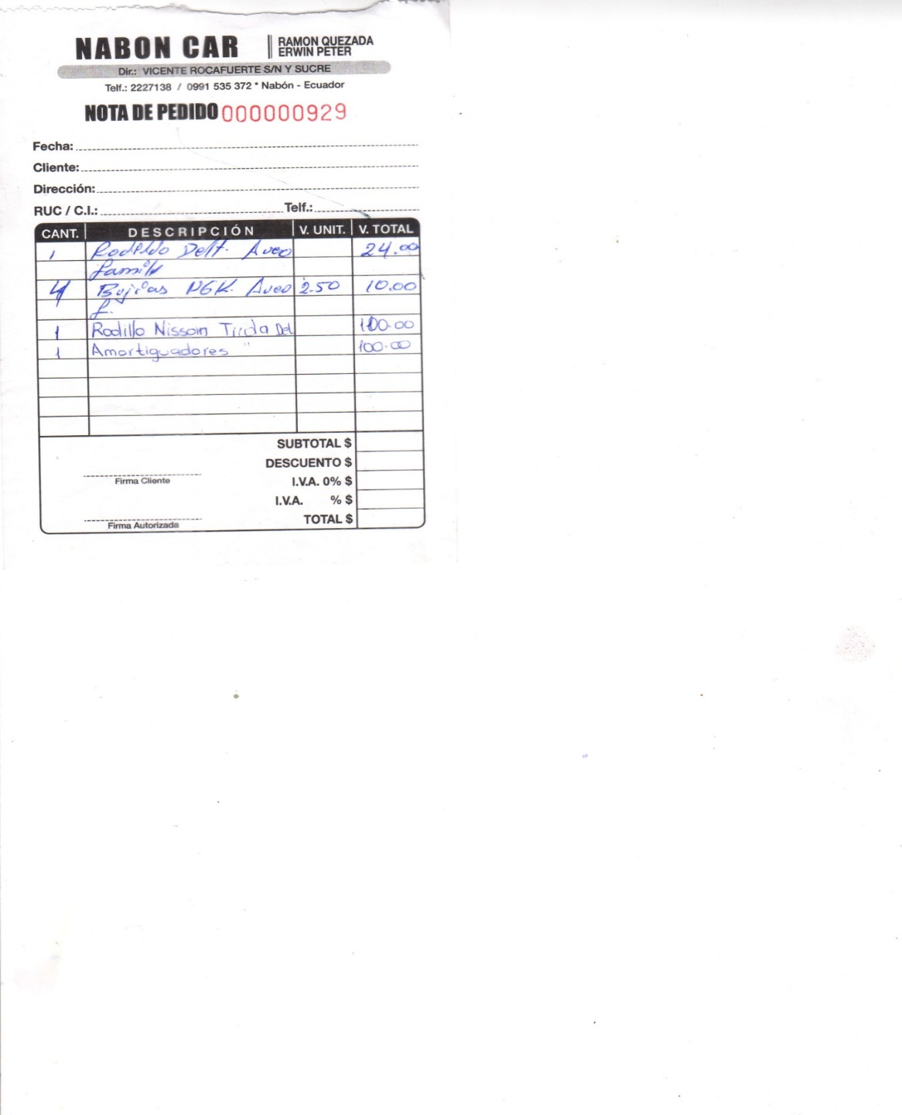

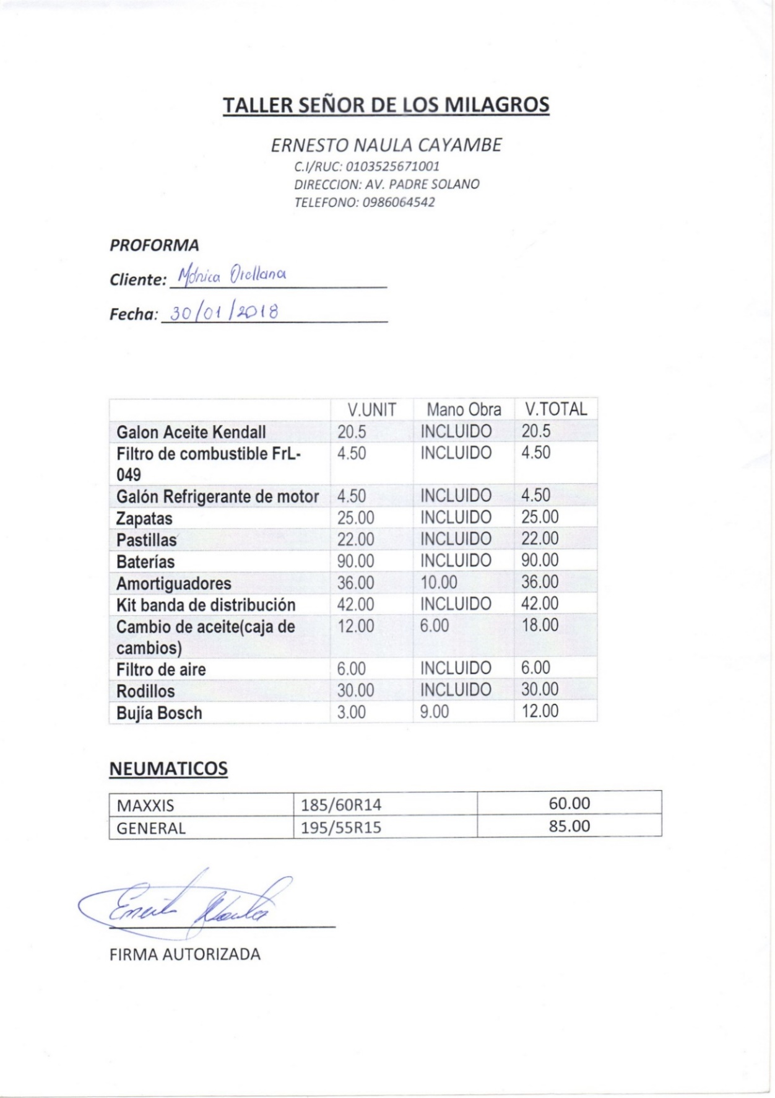

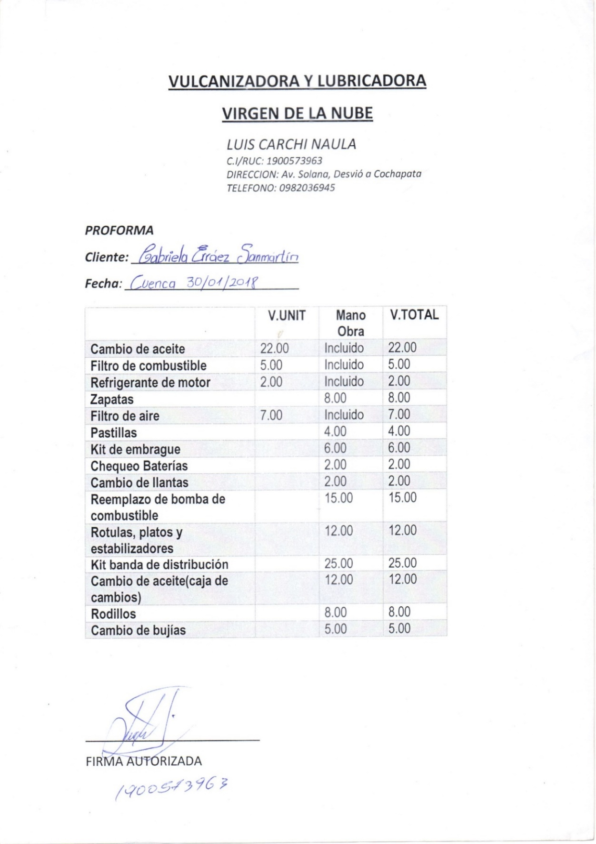

ANEXO 5

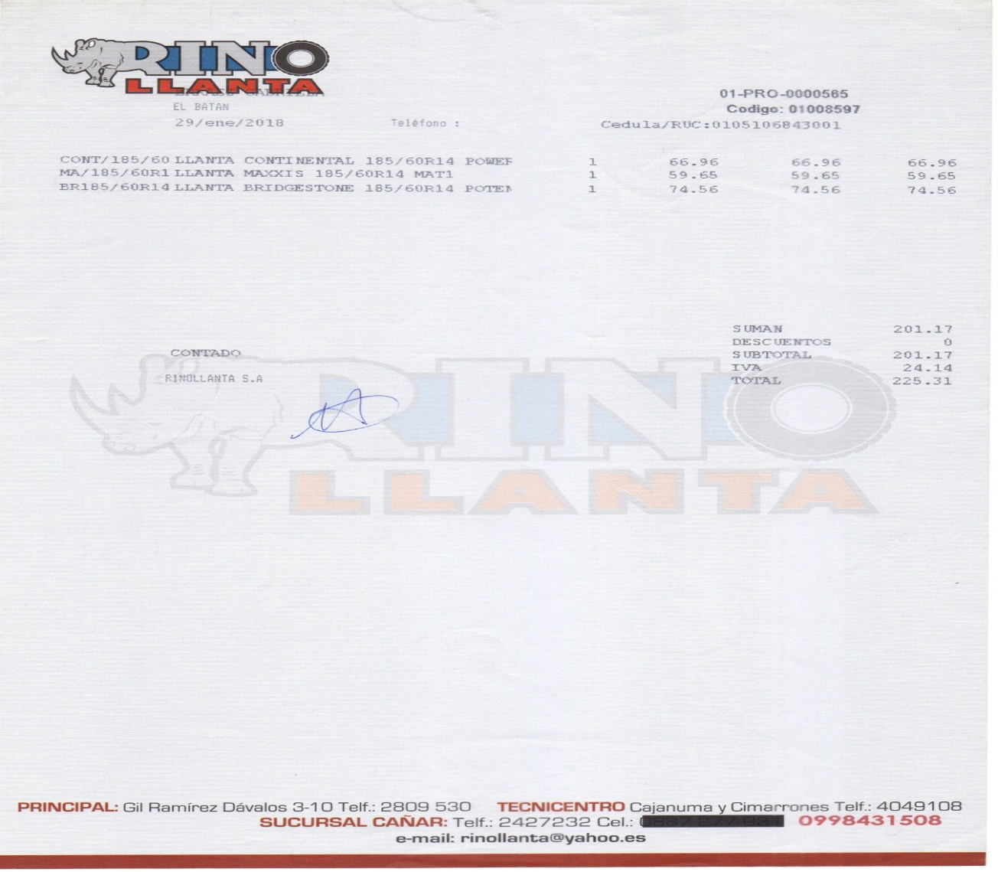
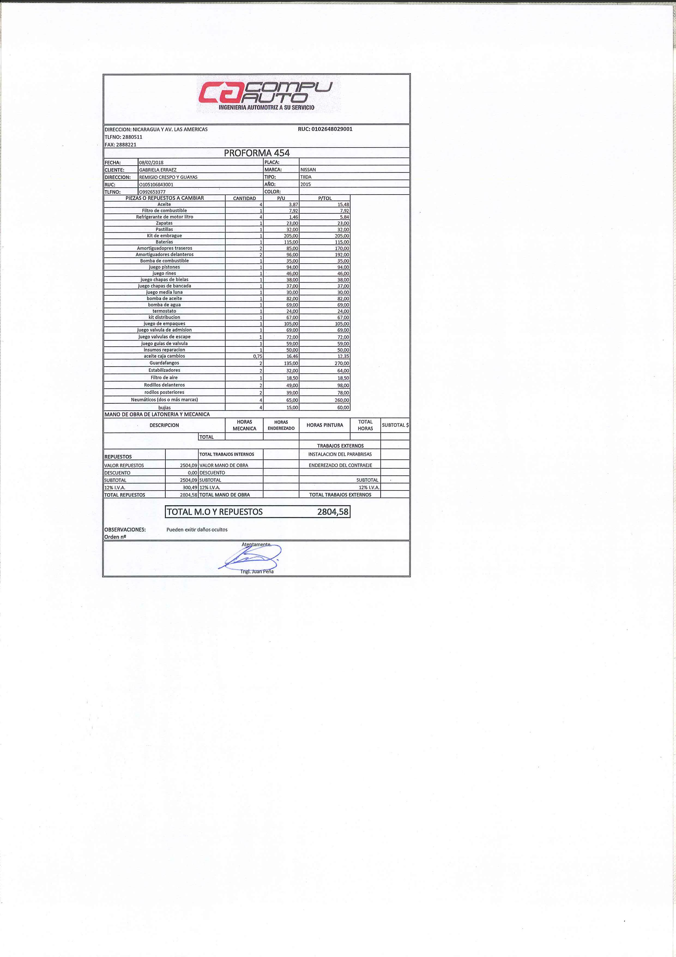
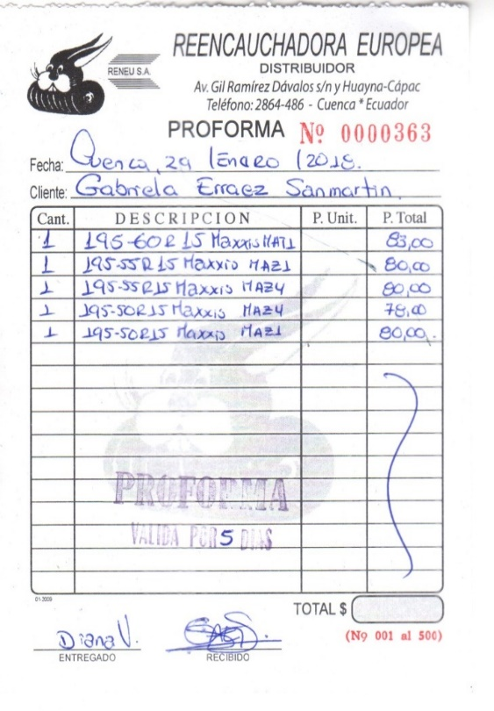
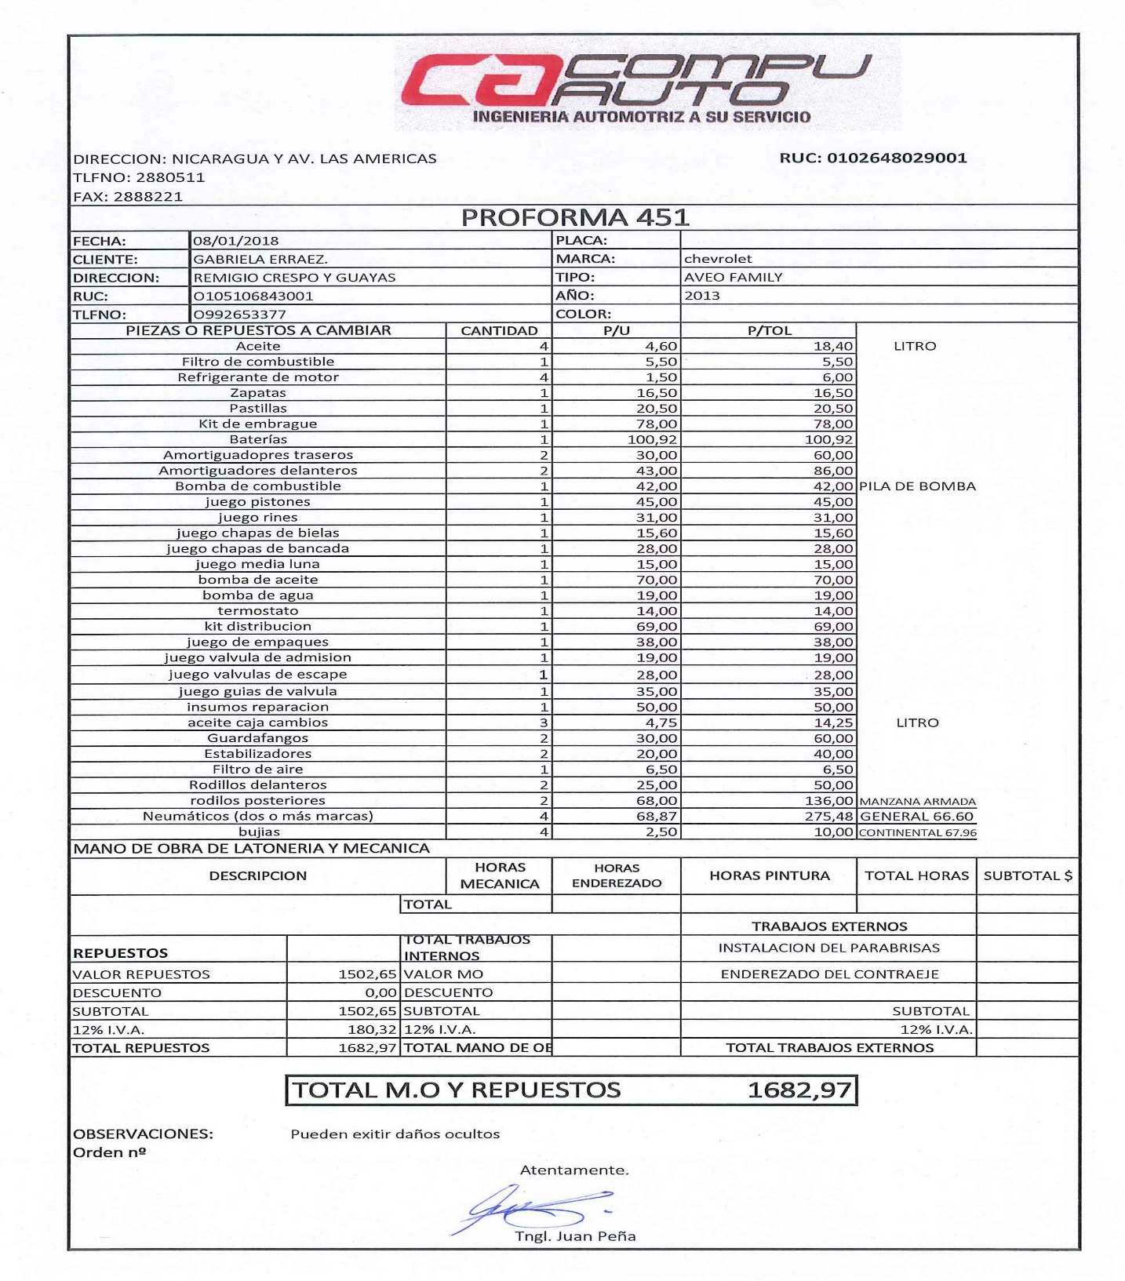

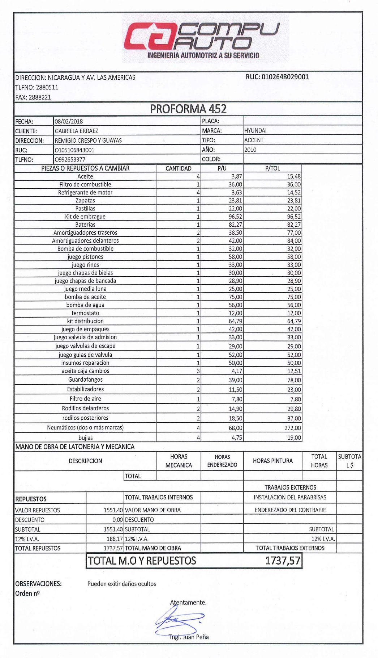

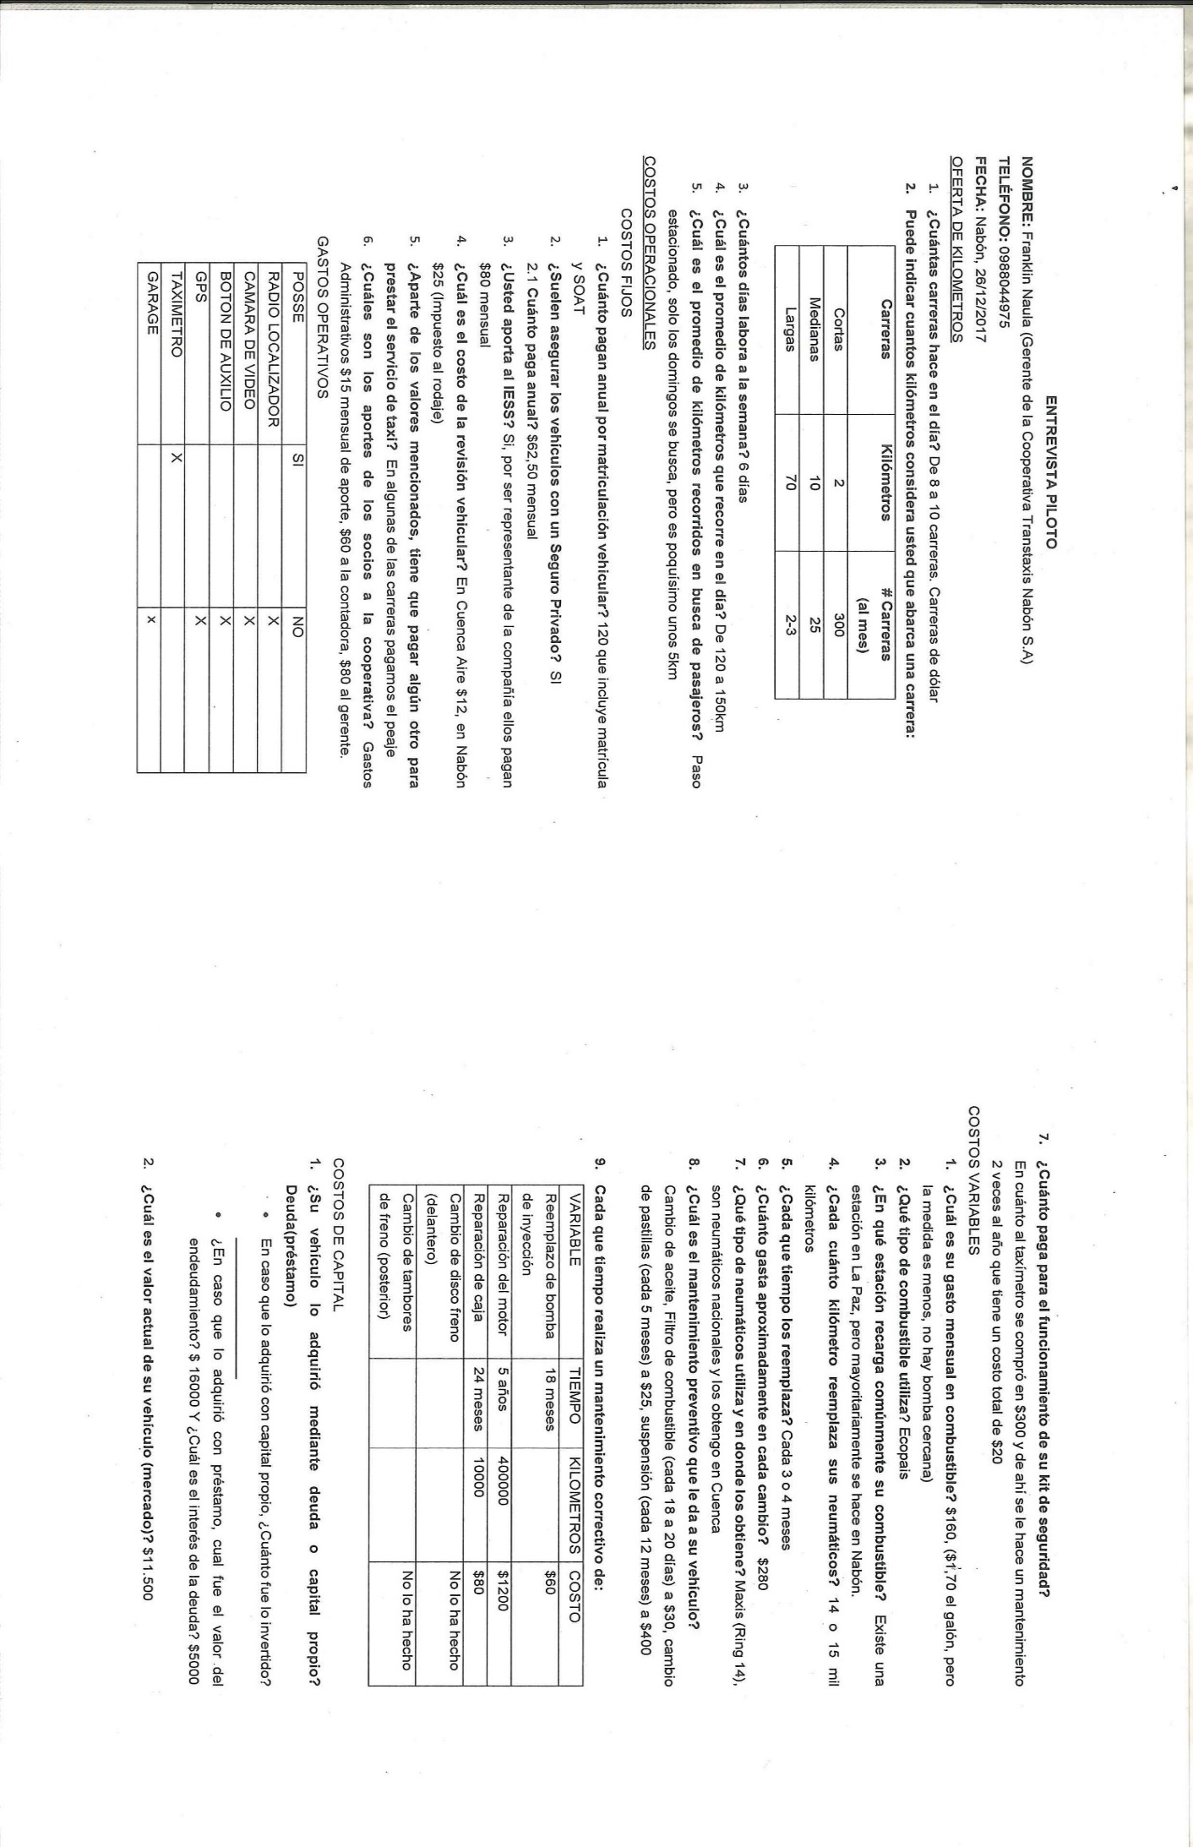
ANEXO 6

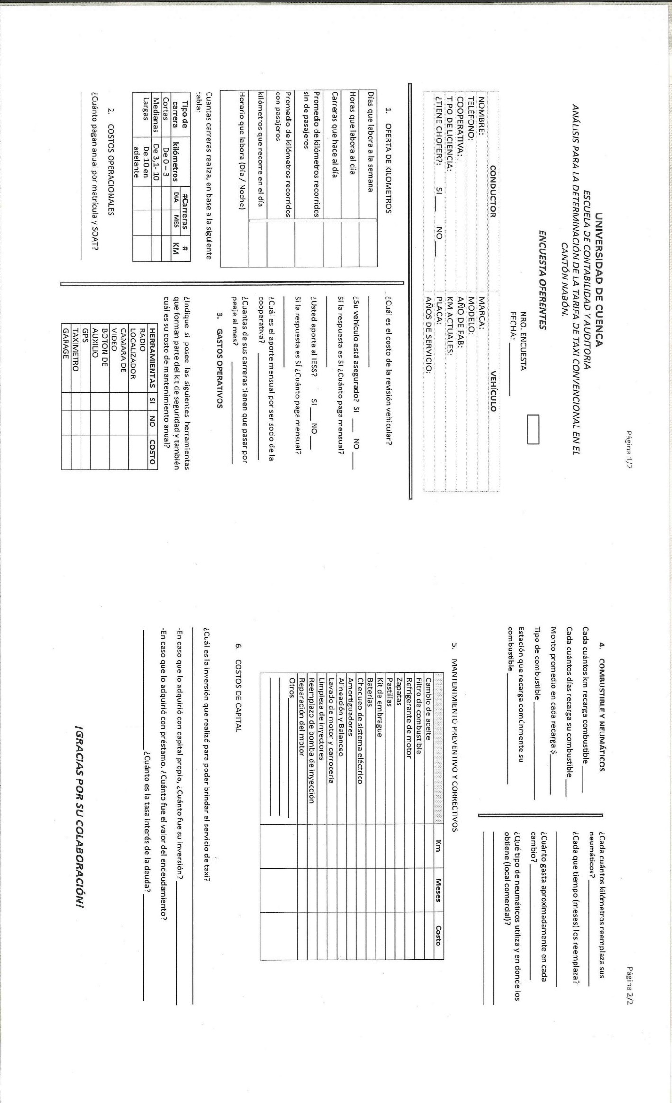
ANEXO 7
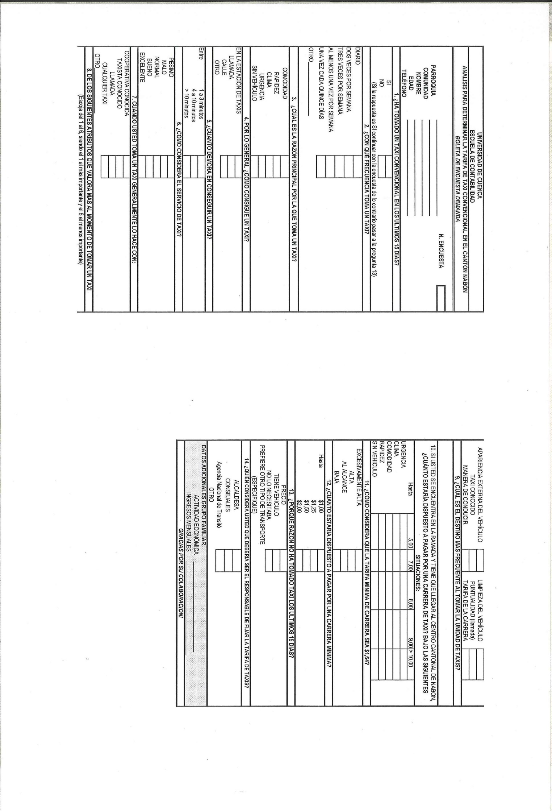
ANEXO 8
ANEXO 9
 |  | MUESTREO EN BASE AL TOTAL DE FAMILIAS
 | AZUAY | NABON | NABON | 2368 | 0,57447841 | 202
 | AZUAY | NABON | COCHAPATA | 821 | 0,19917516 | 70
 | AZUAY | NABON | EL PROGRESO | 550 | 0,13343037 | 47
 | AZUAY | NABON | LAS NIEVES (CHAYA) | 383 | 0,09291606 | 33
 |  |  |  | 4122 | 1 | 351
 | 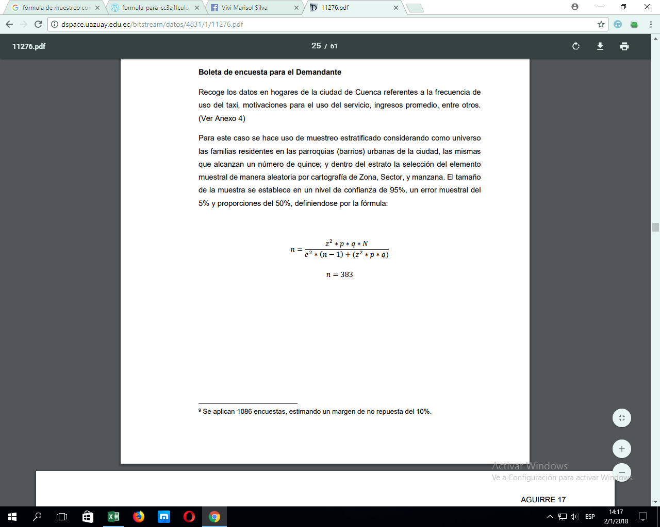
 |  |  |  | z= | 1,96
 |  |  |  | p= | 0,5 | (dado por la formula)
 |  |  |  | q= | 1-p=0.5 | (dado por la formula)
 |  |  |  | N= | 4122
 |  |  |  | e= | 0,05
 |  |  |  | n= | 351

ANEXO 10

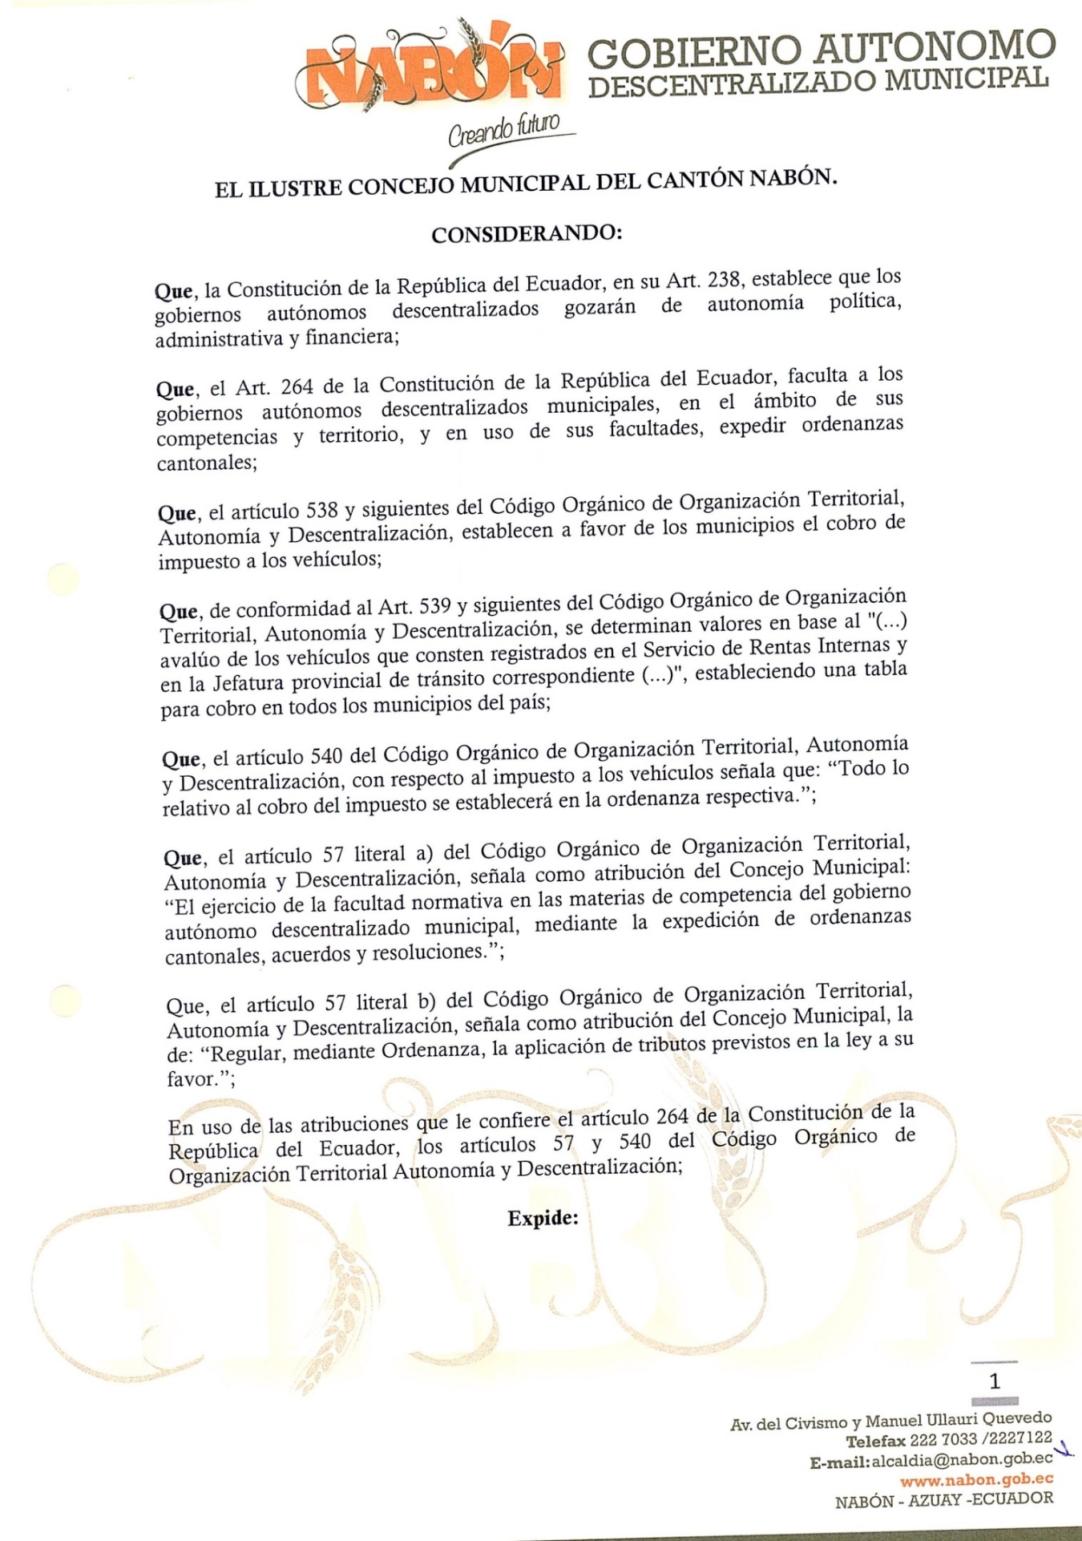

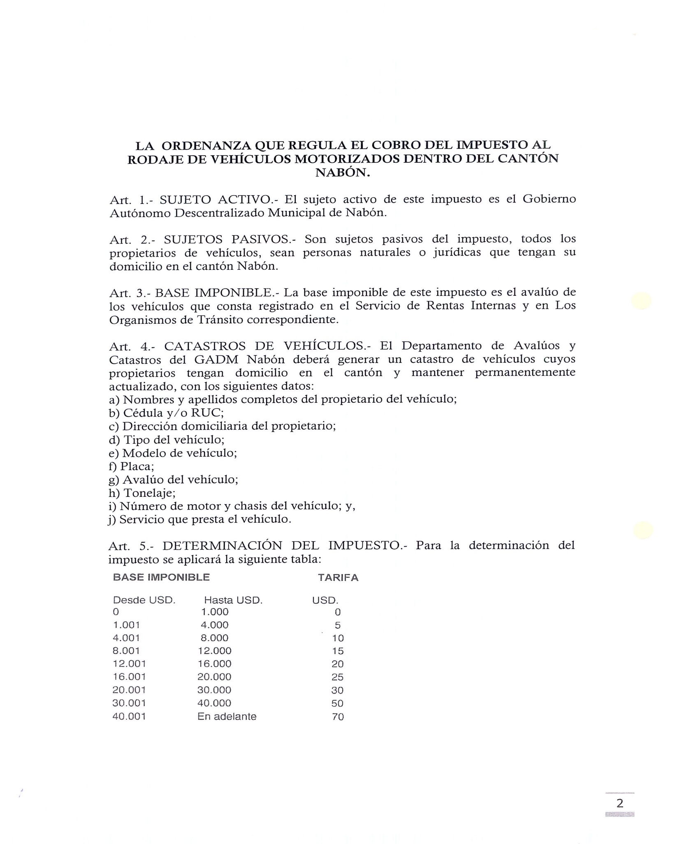

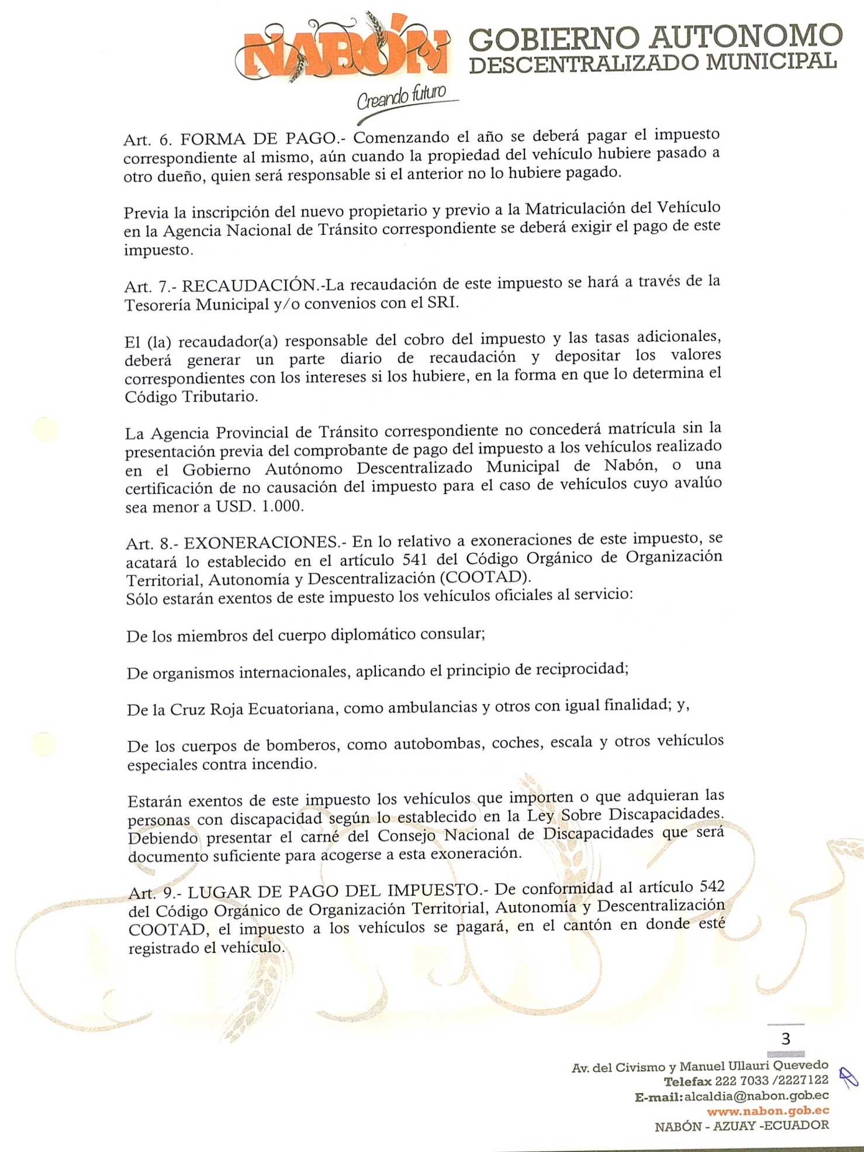
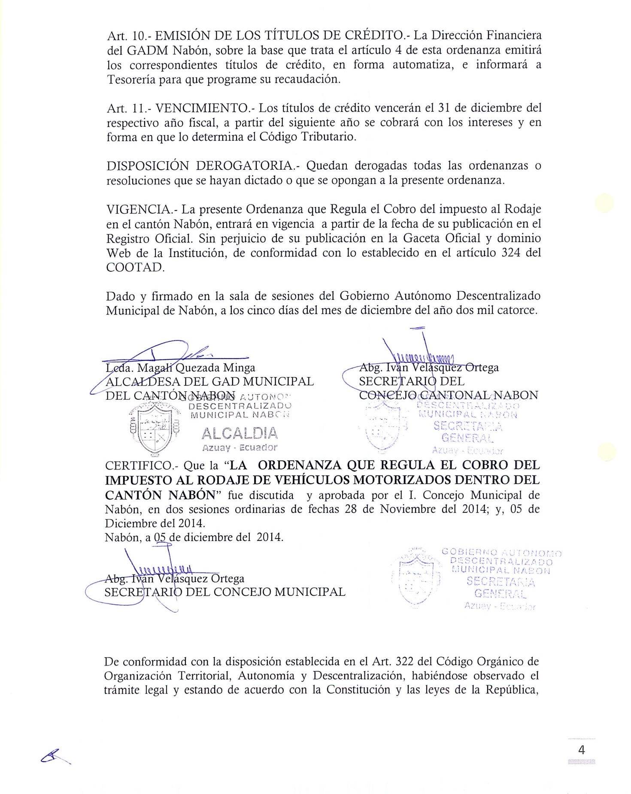
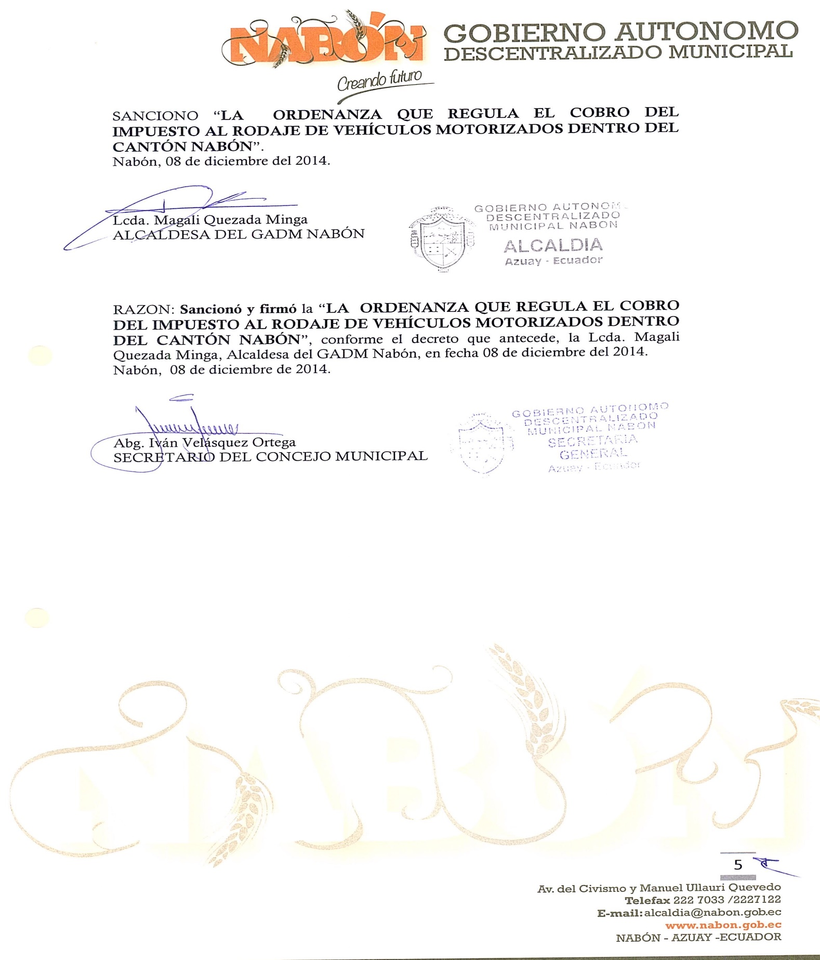

ANEXO 10.1
Valor del impuesto al rodaje según el tipo de vehículo.
Marca | Modelo | Año | Cotización | Imp. Rodaje
Chevrolet | Aveo Family | 2010 | 11600 | 15
Chevrolet | Aveo Family | 2011 | 13200 | 20
Chevrolet | Aveo Family | 2012 | 13500 | 20
Chevrolet | Aveo Family | 2013 | 13900 | 20
Chevrolet | Aveo Family | 2015 | 15800 | 20
Chevrolet | Aveo Family | 2016 | 16000 | 20
Chevrolet | Aveo Emotion | 2008 | 12800 | 20
Chevrolet | Aveo Emotion | 2011 | 14990 | 20
Chevrolet | Aveo Emotion | 2013 | 15500 | 20
Chevrolet | Aveo Emotion | 2017 | 19000 | 25
Nissan | Tiida | 2015 | 19300 | 25
Hyundai | Accent | 2010 | 13500 | 20
Hyundai | Accent | 2014 | 20000 | 25
Hyundai | Accent | 2017 | 21000 | 30
Hyundai | Elantra | 2011 | 18000 | 25

